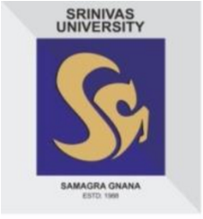SRINIVAS UNIVERSITY

COLLEGE OF COMPUTER SCIENCE & INFORMATION SCIENCE
Master of Computer Application (MCA – Dual Specialization)

Introduction about MCA - Dual Specialization
Srinivas University, at its City Campus, Pandeshwara Mangaluru is offering MCA programme in Dual Specialization (Networking & Software Development, Data Science/Cloud Computing with IOT) for the upcoming academic year 2021.

Course Features:
The MCA programme of Srinivas University is a Two-year course designed with the primary goal of imparting a uniquely broad, yet intensive IT education of the highest academic quality. It focuses on the areas like Software Development, Web Design & Development, Cloud Computing, Network management, Mobile Technologies and Big Data. The programme has been designed with a focus on delivering the latest, industry-oriented education in computer applications with a sound theoretical and practical approach to learning.

The MCA course curriculum with its industry-relevant course structure and certification programme prepares students for various positions in IT industry. ‘On-the-job’ trainings, study tours, and skill enhancement events and workshops are extensively integrated in curriculum. They expose students to real work environments and provide an opportunity to apply their learning in real life situations.

Career Opportunities:
Srinivas University has collaborated with several IT companies for providing its students with industry immersion through internship programme. It offers various opportunities for students to work directly with industry on Live and Entrepreneurial projects. Industry projects give our students insights about latest trends in the corporate world and help them become competitive and ready for the real world. After successful completion of the course, MCA graduates may opt for roles such as Business Analysts, System Analysts, IOT engineers, Cloud Architect, Data Analyst, Data Scientist, Database Administrators, Network Professionals, Software Testers, Web Designer and Developers, Programmers and Managers in any field related to information Technology and Information Management. The expected job profiles and placement opportunities with attractive salary offering are guaranteed.

