OceanMedallion
Next-Gen Cruise Technology.
(It is The Bounce Back to Cruise Industry in This Pandemic)

By,
Kaushik M
Asst. Professor
Srinivas University College of Hotel Mgt. and Tourism
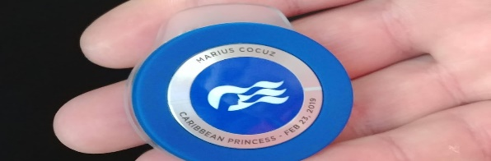
The cruise industry is at the precipice of the next wave of cruise technology, created to enhance cruise vacations by allowing cruise lines and passengers alike to customize the cruise experience. One of the first adapters of the new technological ideology is Carnival Corporation, which has created the OceanMedallion program. But what exactly is it?
The OceanMedallion is a piece of a Carnival Corporation initiative dubbed OCEAN, or One Cruise Experience Access Network, that combines several technology-driven initiatives with the OceanMedallion as the flagship element.
The Medallion -- which is used on most of the cruise -- itself is a free, wearable casino chip-sized disc that serves as an access point to information about you (i.e. your "digital identity") so that you can personalize your onboard experience. Medallions are blue, gold, red, silver and black in color (depending on your Captain's Club loyalty status)
The Medallion is scanned by thousands of sensors on the ship, as well as in the Port Everglades terminal and on Princess Cays, enabling cabin doors to be unlocked by the time the rightful occupant arrives at the door, or pay for purchases.
OceanMedallion facilitates many cruise ship functions and services, beyond serving as a door key and onboard credit card.
Ordering food and drink: Once onboard, cruisers can use the Medallions for on-demand food and beverage service (plus select retail items). To do so they must have the MedallionClass app, in which they'll find a section called OceanNow. From there, passengers can order from a menu of food and beverage items and have it delivered almost anywhere on the ship.
Cruisers can also use the Medallions for onboard navigation via the OceanCompass app or with interactive wall portals that "recognize" cruisers' Medallions and can offer real-time wayfinding and location services. Those with the OceanCompass app can do the same thing directly on their smart phones.
Another piece of the larger MedallionClass Experience is MedallionNet, a high-speed internet system that has been designed to withstand inclement weather and maintain service even in areas of spotty connectivity. It's strong enough for streaming TV; you can even teleconference using the Wi-Fi without any issues.
The Medallion token can be carried in your pocket, worn on a lanyard around your neck, clipped onto your clothes or worn as a wristband, bracelet or pendant.
the token is free, as are many of the services it can provide and all the apps. Accessories, such as wristbands and necklaces, designed to hold the Medallions do cost extra, with prices starting at $8 and going as high as $65. All guests are given a free lanyard prior to boarding.
And also OceanMedallions do not actually carry any data on them. They are conduits to information stored (and encrypted) somewhere else; your information is actually parsed and stored in multiple places so that no one data center has all your info. The Medallion can help deliver information to a number of receivers: tablets carried by crew members, interactive displays on the ships, etc. Were anyone to actually hack the Medallion, all they'd get is a number, with no meaning and no information attached to it.

