2019 -20
ECE

➢ OFFICE BEARERS OF STEADY FOR THE ACADEMIC YEAR 2019-20

PRINCIPAL DR. SHRINIVASA MAYYA D
HOD (ECE) DR. SOORYA KRISHNA K
FACULTY ADVISOR MRS. FLAVITA JANICE PINTO
PRESIDENT ARAVIND RAO K
VICE PRESIDENT DHANYASHREE
SECRETARY NIKITA CHARI
JOINT SECRETARY SHRAJAN CHOWTA
TREASURER VINAYAK S KALGUTKAR
EDITORS ACHARYA SUMAN
SHRIVIDYA

➢ WORDS OF APPRECIATION

FROM THE PRINCIPAL’S DESK
“I am indeed very happy to know that our ECE students association STEADY is bringing out the newsletter ‘INCHARA’. Young and talented engineers of tomorrow with in depth technical knowledge will be an asset to our country in all round development. In this regard, the newsletter will provide a little contribution from students side related to the activities of the department of the college. I wish all the success to the budding engineers.”

- DR. SHRINIVASA MAYYA D

FROM THE HOD’S DESK
“It gives me immense pleasure to present the yearly Newsletter of Electronics and Communication Department, SIT. The newsletter of ours is a humble effort to showcase the talents of our Students, Faculties and the Activities conducted by the department Association “STEADY” during the academic year 2019-20. I thank the Association Staff Coordinator and the Student Editorial board for the tired-less effort to bring-out this issue.”

- DR. SOORYA KRISHNA K

KRIYA KALAPA

INAUGURAL FUNCTION OF STEADY 2019-20

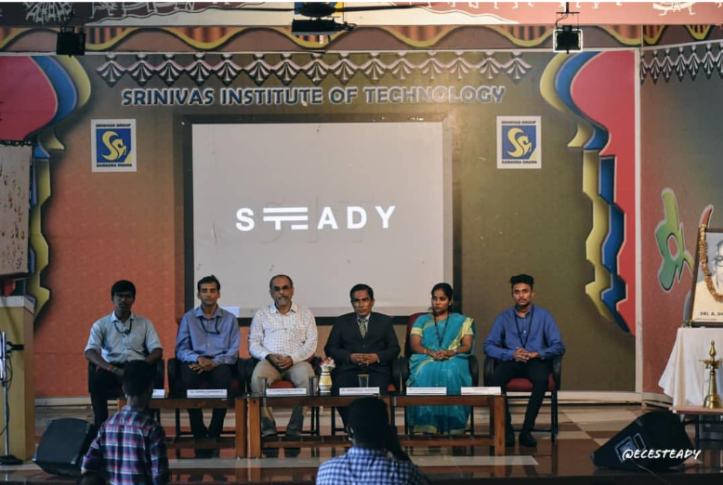

Inaugural function of the association of electronics and communication department ‘STEADY’ was held on 12th September 2019. The secretary in charge of STEADY association Mr. Indresh C. welcomed the dignitaries. The association was inaugurated by the chief guest C.A. Ghiridhar Kamath.
The event coordinator of the association Mr. Abhilash Badiger introduced the chief guest C.A. Ghiridhar Kamath to the gathering. Mr. Ghiridhar Kamath stressed on Professionalism and Society briefing on how to reach out to society for spreading awareness and knowledge. He also spoke on importance of communication and listening skills in today’s world.
The inaugural function was presided by Principal Dr. Shrinivasa Mayya D. He stressed on various skills that can be developed through active involvement in the association. The Head of the department Dr. Soorya Krishna K encouraged the students to conduct activities at the departmental level.
President of the association Mr. Aravind Rao read out the work plan of STEADY for the academic year 2019-2020. Sports in charge of the association Ms. Amulya introduced the office bearers of STEADY 2019-2020 to the gathering. The function ended with a vote of thanks by the Vice President of the association, Ms. Dhanyashree. The inaugural function was followed by an activity conducted by C.A. Ghiridhar Kamath which was mainly concentrated on how to interact with society.
.

APTICRACK1

‘APTICRACK1’ was conducted in the department of Electronics and Communication Engineering of Srinivas Institute of Technology, Valachil, Mangalore in association with ‘STEADY’. This event was conducted on 4th October 2019. Event comprised of one round. 60 teams, 2 members in each team participated in this event. | 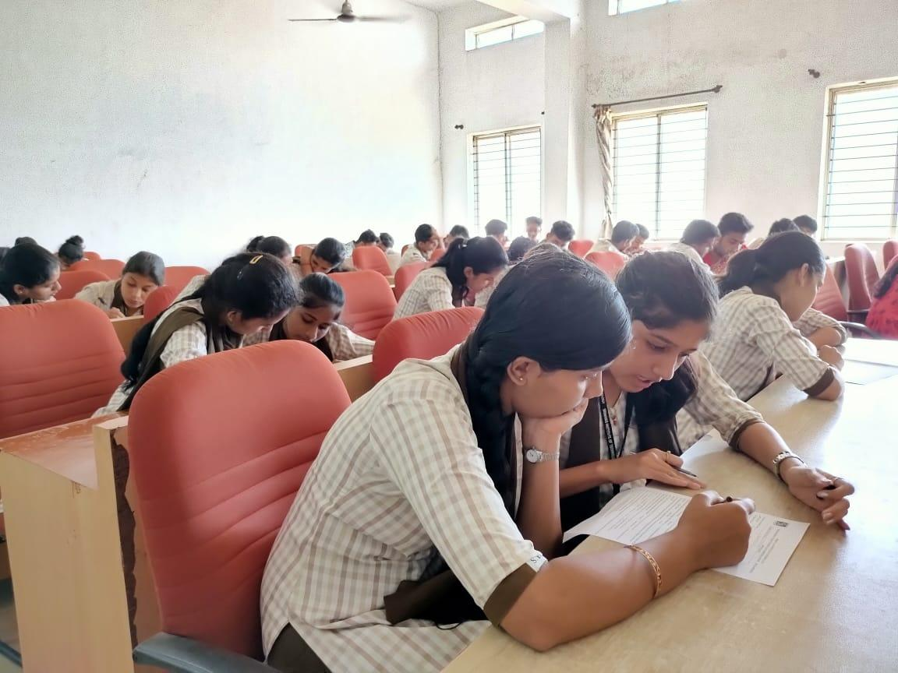
Winners of APTICRACK1 are:
1st place: DELRIN and FAHIQA (7TH SEM ‘A’)
1st place: VINAYAK P K and SATHYAPRAKASH (7TH SEM ‘A’)
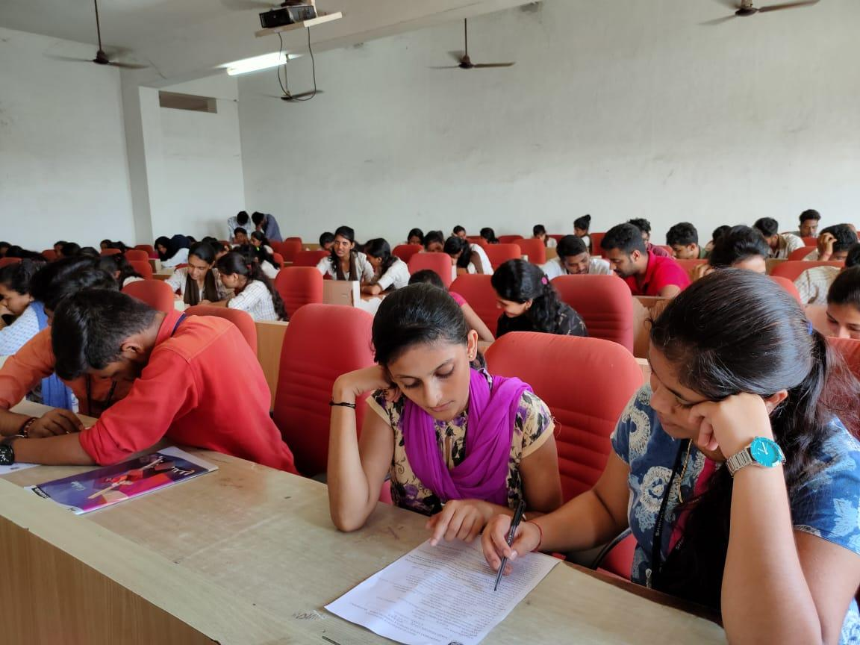

➢MOBILE PHOTOGRAPHY

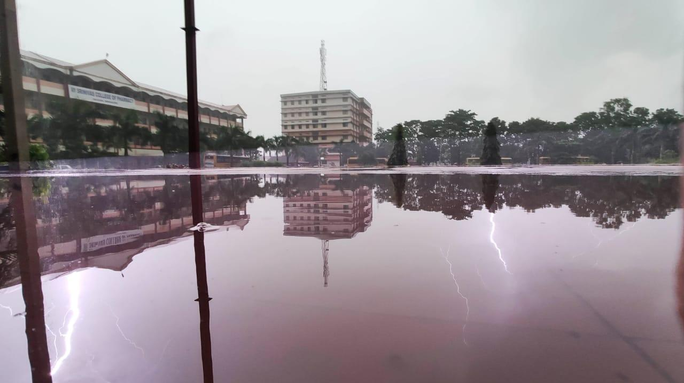

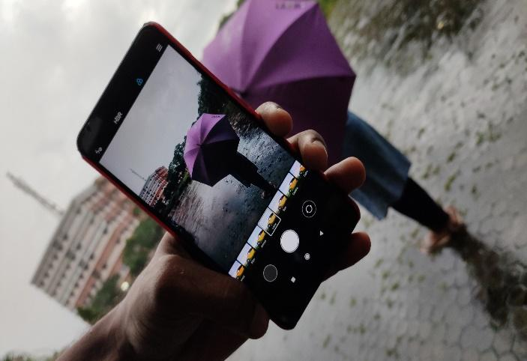
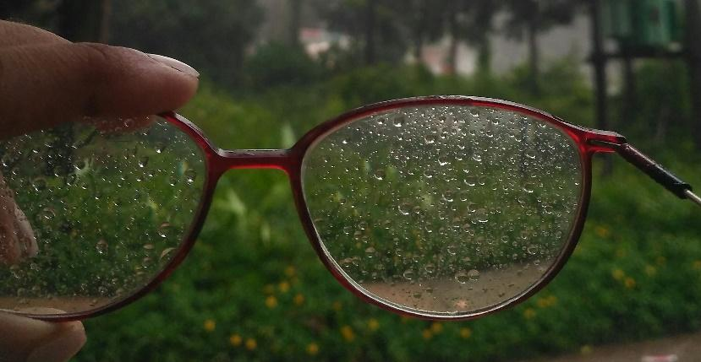
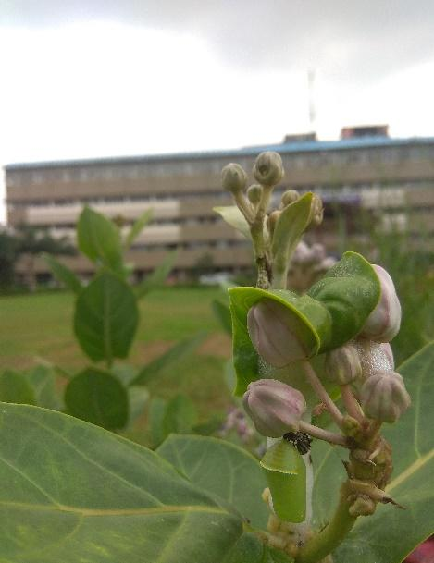

Association of Department of Electronics and Communication Engineering ‘STEADY’ organized a mobile photography event on 16-10-2019. The topic given was ‘Beauty that captures your eyes’. Total 18 photographs were submitted based on the topic. The winner was decided by Prof. Amardeep, Assistant Professor, Department of ECE.

Winners of MOBILE PHOTOGRAPHY are:
First place: Pooja Y Kori
Second place: Amadalli Sarvesh Alias Ganesh

➢ PAPER BAGS

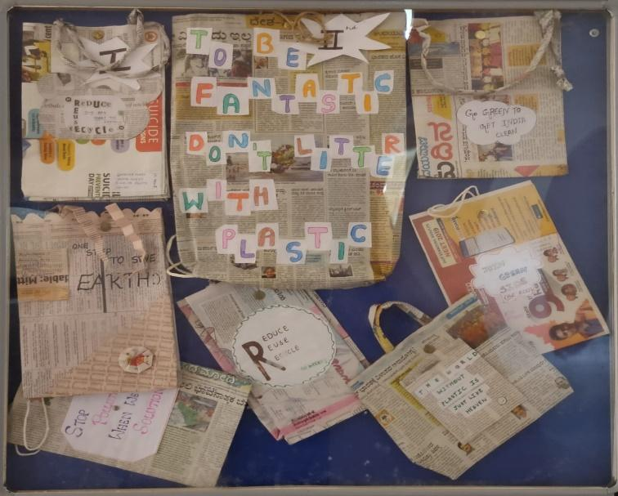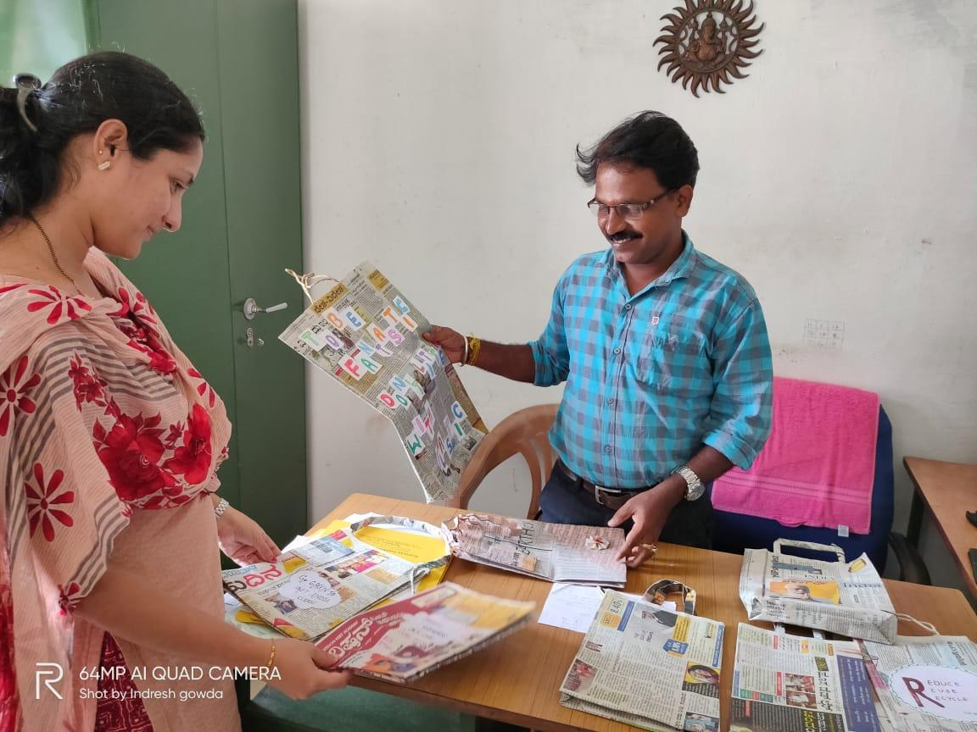

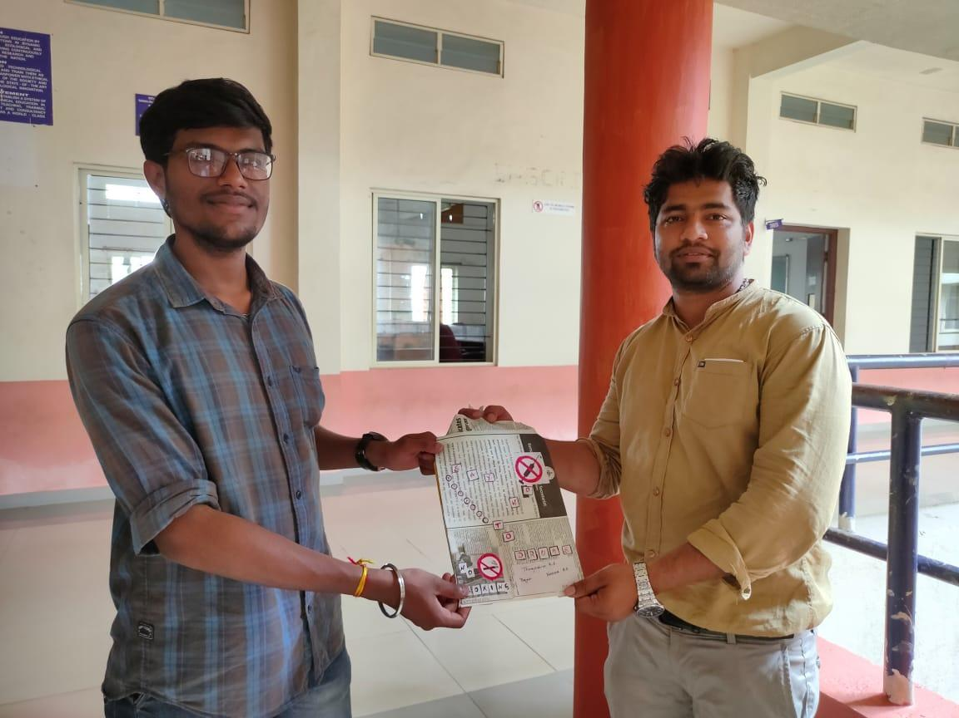

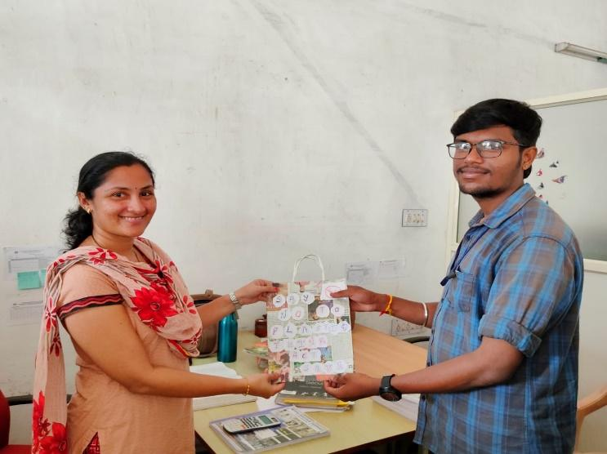
“Nature is for everyone’s need but not for anyone’s greed so discard plastics from environment"
They are bad, destructive, non-biodegradable and well, just not cool! Plastic bags are to the environment what frenemy is to you. It may look quite useful, but with time it only harms us. The environment needs natural space just like us to work properly. With this thought in mind the association of department of Electronics and Communication Engineering ‘STEADY’ conducted a ‘Say No to Plastic’ campaign on 28th September 2019.
The students of the department went to various departments to spread this noble awareness. A theme based Paper Bag Making Competition was also held. The center of attraction was the display of paper bags all over the college campus, with quotes on ‘Say No to Plastic’. The students had an exceptional exposure in terms of learning and sharing.
The overall program was fruitful. The enthusiasm of the staff and the students towards the campaign made it more educative. This event was judged by Prof. Sathish Kumar K and Prof. Deeksha.
The winners of this event are:
First place: Dhanyashree, Bindya, Janyashree, Gouri
Second Place: Shipra, Sheethal, Pooja, Kavya M S

➢ TECHNICAL CROSSWORDS

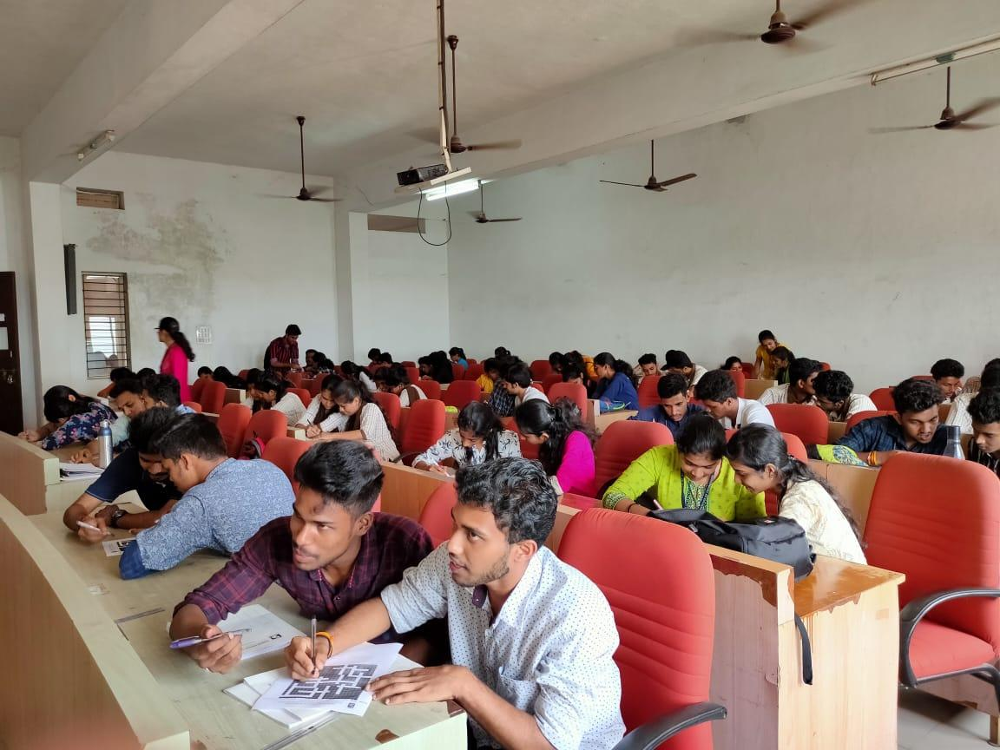

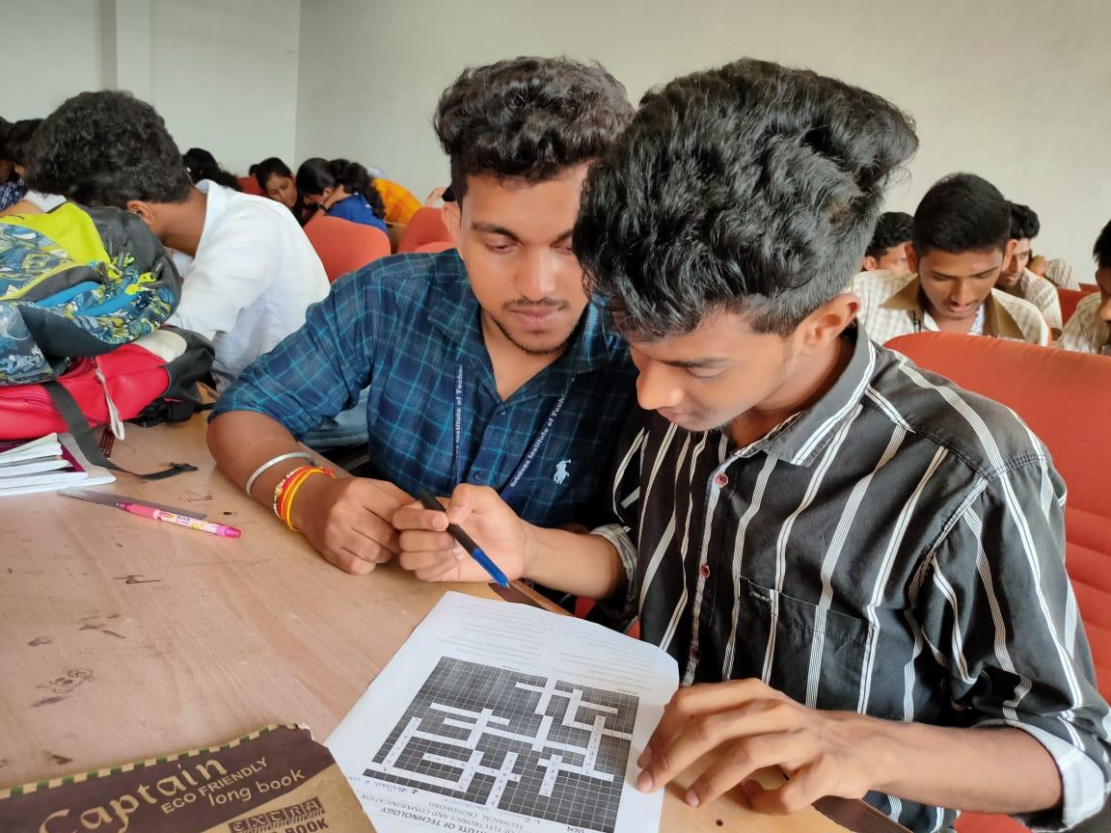

‘TECHNICAL CROSSWORD’ was conducted in the department of Electronics and Communication Engineering of Srinivas Institute of Technology, Valachil, Mangaluru in association with ‘STEADY’. This event was conducted on 9th October 2019. Event comprised of one round. 40 teams, 2 members in each team participated in this event.
Winners:
1st place: VINAYAK P K AND SATYAPRAKASH (7th SEM ‘A’).

➢ VRIDASHRAM VISIT
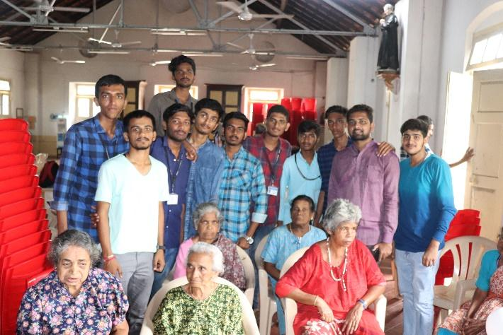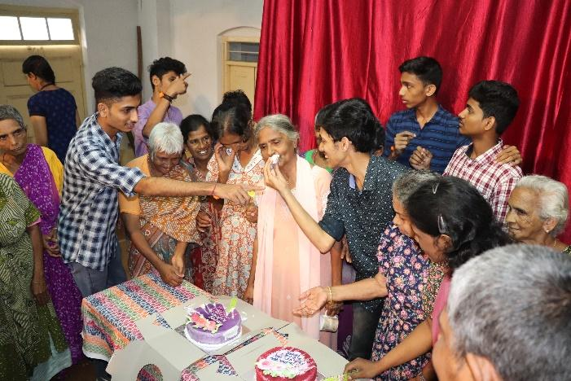
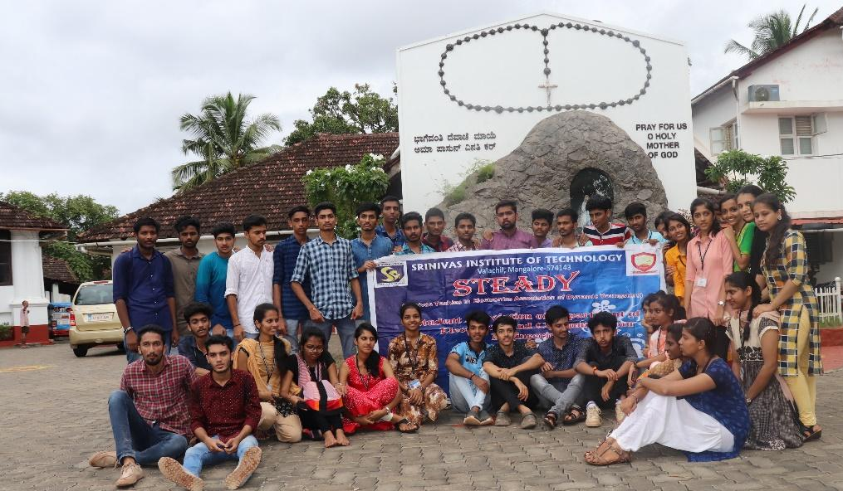
Students of 3rd semester SIT ECE visited St. Anthony’s Poor Home (Vridhashram) on 25th of September 2019. Various activities were performed between 10.00 AM to 1.00 PM as the outreach program. They performed various entertainment programs for old age people and then interacted with them.

➢ swatchata abhyaan

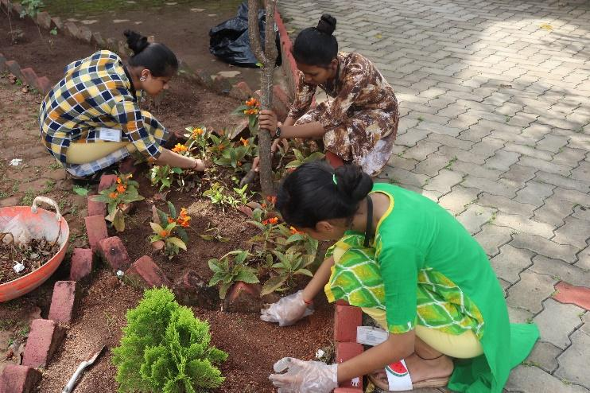
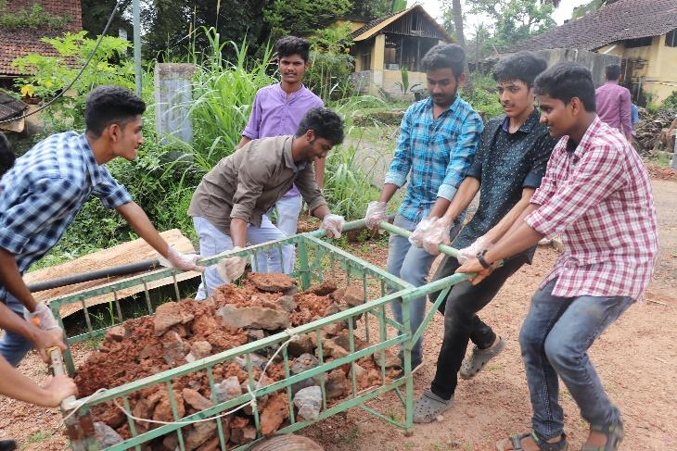

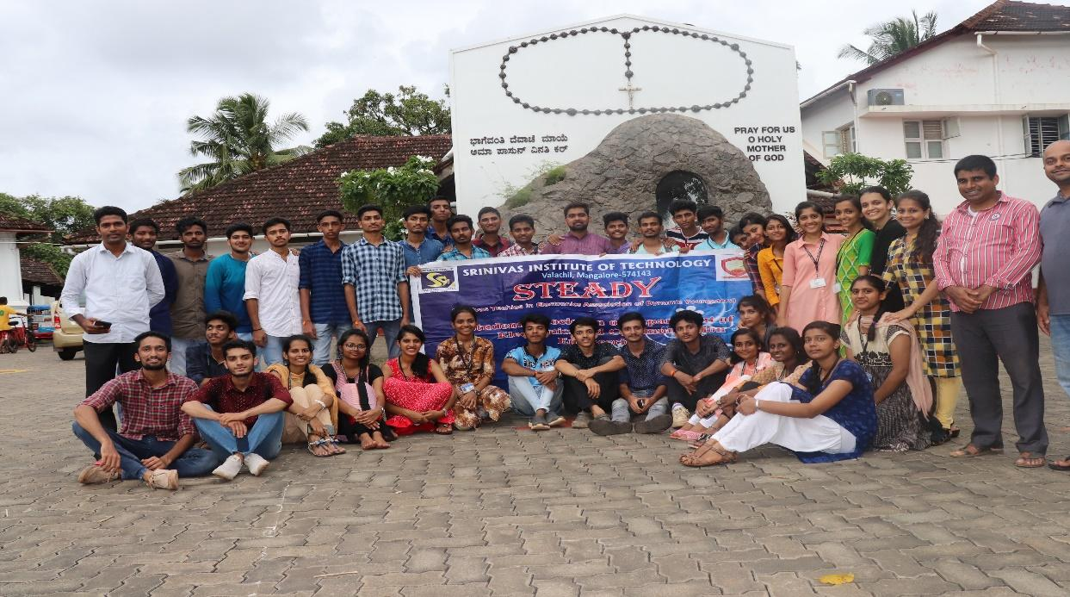

Students of 3rd semester SIT ECE visited St. Anthony’s Poor Home (Vridhashram) on 25th of September 2019. Ashram surroundings were cleaned by the students and other assigned work were completed by the students from 2.00 PM to 4.30 PM as the outreach program.

➢ GUDUDEEPA COMPETITION

Festival of lights is round the corner. The time to take out sky lanterns from the closet and give them a new coat of colour paper is here. As a part of Deepavali, association of Electronics and Communication Engineering ‘STEADY’ organized Gududeepa competition. Gududeepa event was held on 12th October 2019. 5 teams comprising of maximum 4 members in a team participated in the event. Through this competition, we aim to keep alive the art of making Gududeepa.
WINNERS:
FIRST PLACE: DELRIN, FAHIQA, VAIBHAVI
SECOND PLACE: KARTIK, JEEVAN, SHASHANK, SACHITH
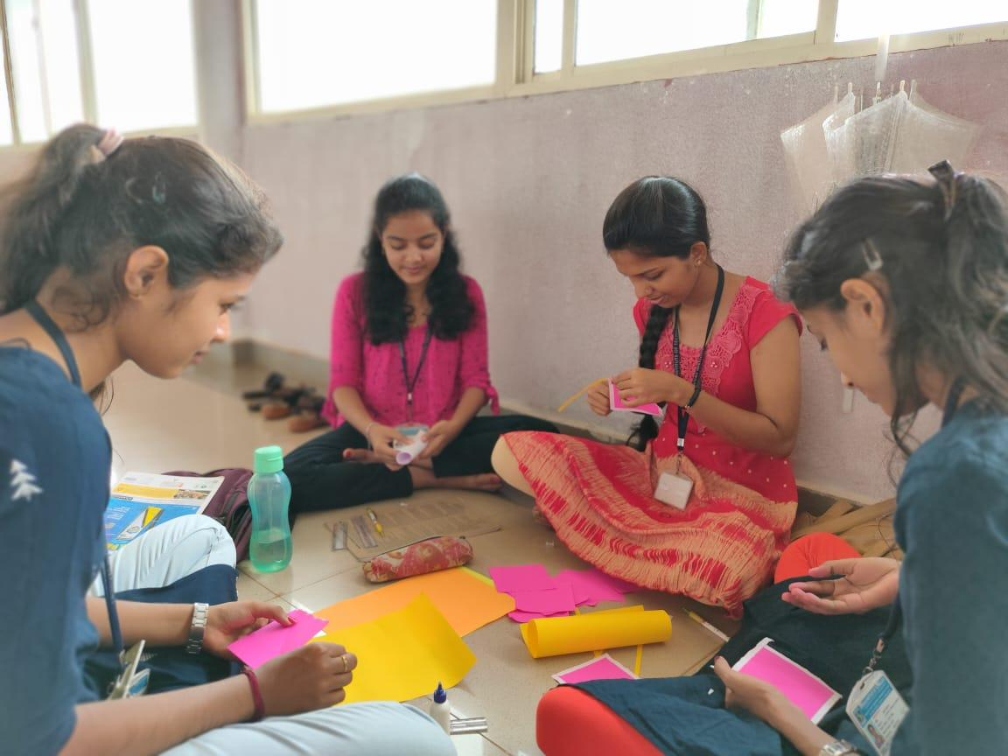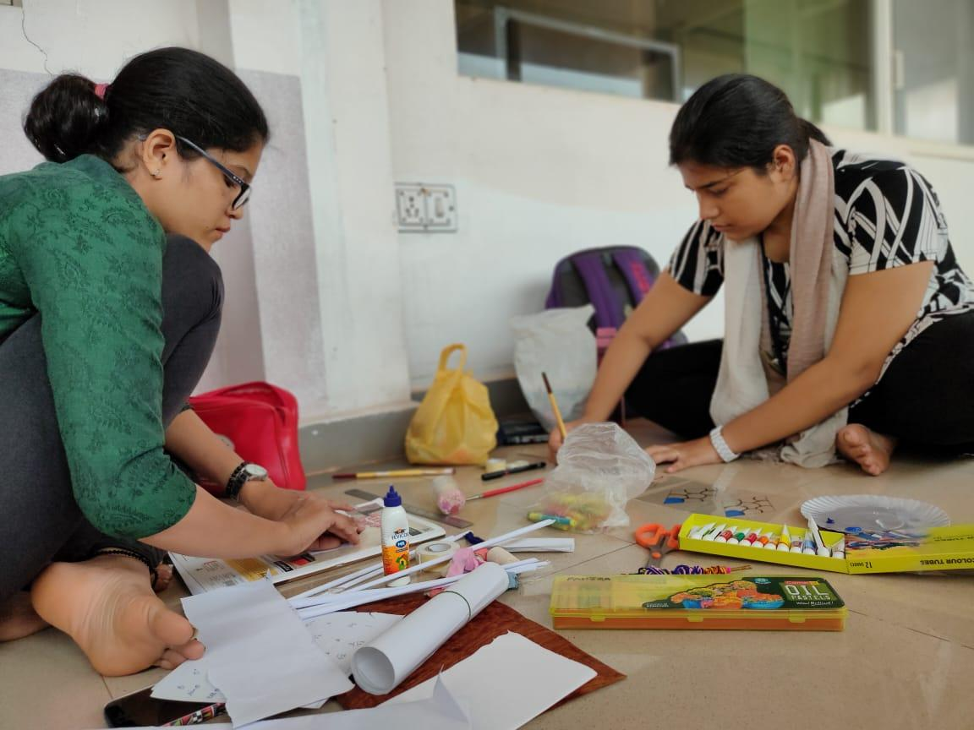

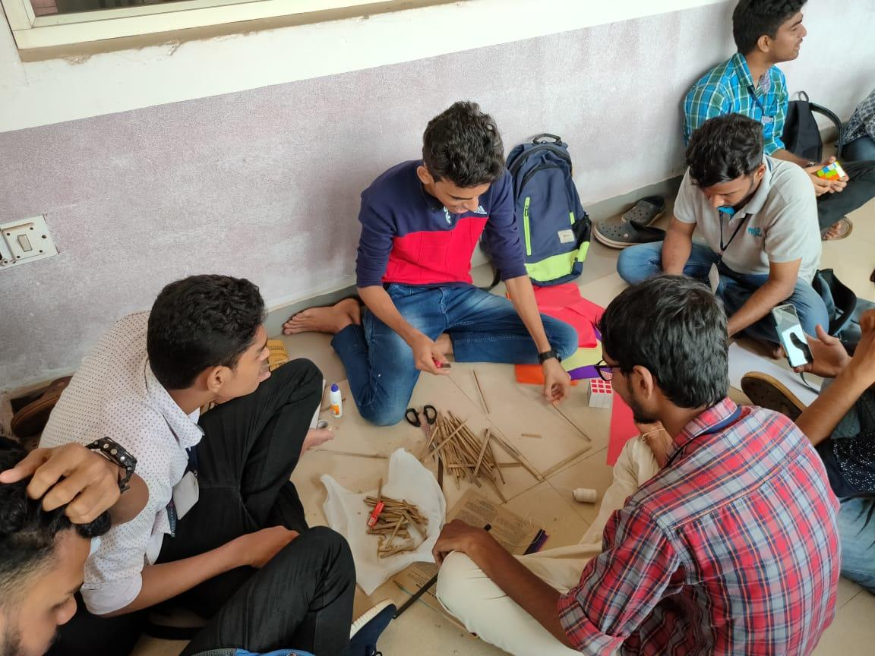

➢ORPHANAGE VISIT

Association of department of Electronics and Communication Engineering, ‘STEADY’ organized a visit to Bala Samrakshana Kendra an orphanage in Kuttarpadav, Mangalore on 10th February 2019. Several programs were organized and games were conducted to create an atmosphere of joy and oneness. Clothes were distributed to the students as a token of love. 30 Members of ‘STEADY’ visited the ashram. Bala Samrakshana Kendra houses more than 100 children and provides them with all basic needs. Ashram is looked after by Mangala Seva Samithi Trust. Students also contributed to the betterment of the ashram and offered refreshments to the children.

MEGA EVENTS

➢altius
As per the culture of Srinivas Institute of Technology, every year college organizes an inter department event for students with a very high competitive spirit to participate.
For the preceding academic year 2019, the STEADY association under department of electronics and communication engineering organized various events with the objective to provide platform for the students to showcase their talent with a competitive spirit.
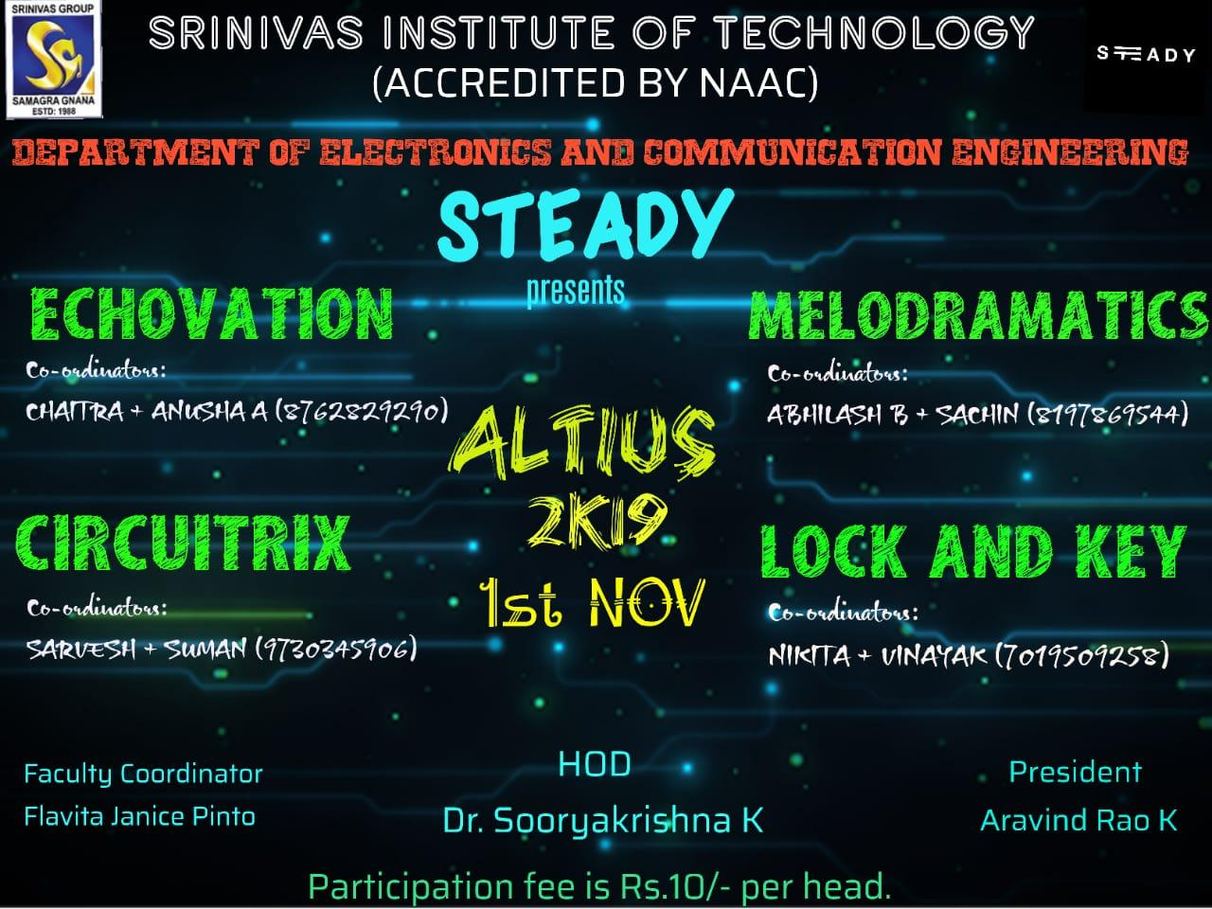
The fest executed with a total of 6 events planned and organized at its best of quality. Technical events like Paper Presentation, Hardware & Software Debugging as well as fun events like Tech Charades, Snapdragon, Rangoli and Kite Flying was equally planned to gather maximum response.
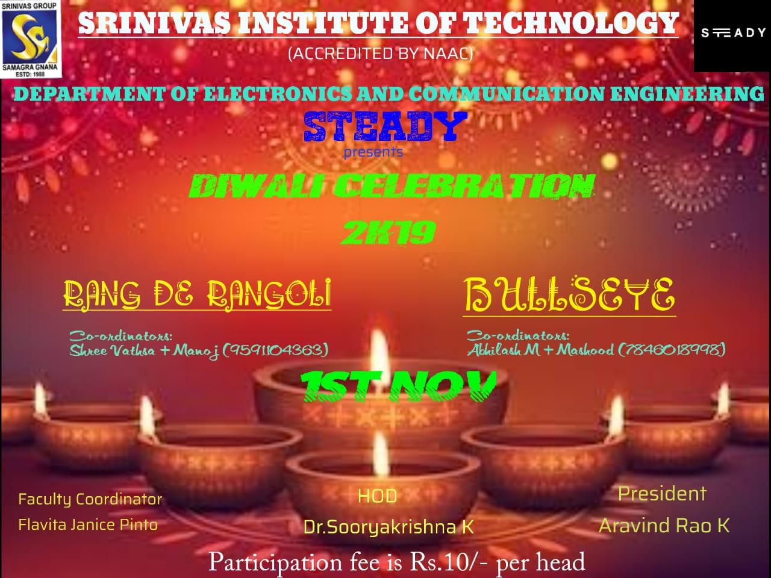
The event was successful enough to attract a good number of registrants. As far as paper presentation event into consideration the paper scrutiny needed to be done and submitted before the event to give opportunity to present best innovative idea. The winners were encouraged with good trophies. Department feels proud to organize such a successful event and would like to convey thanks to Principal, HOD and management for their timely advise and cooperation for organizing the events.

WINNERS LIST
NO | EVENT | TEAM | USN | PLACE
1 | Echovation | Fathima Fahiqa Firdous  Delrin Jean Dmello | 4sn16ec028 4sn16ec026 | First
2. | Circuitrix | Jagadish M A | 4sn16ec032 | First
 |  | Lakshminayana  Sharanya K | 4sn18ec021  4sn18ec033 | Second
3 | Melodramatics | Giri Vaibhavi  Fathima Fahiqa Firdous | 4sn16ec030  4sn16ec028 | First
4 | Lock And Key | Varun  Vinayak  Sathyaprakash | 4sn16ec708  4sn16ec070  4sn14ec066 | First
5 | Rang De Rangoli | Soujanya S H  N A Akshatha  Reshika  Ashwini | 4sn16ec070  4sn16cs057  4sn16ec706  4sn16ec701 | First
6 | Bulls Eye | Sushanth  Sachith  Yashas | 4sn17ec017  4sn17ec037  4sn17ec055 | First

➢envision

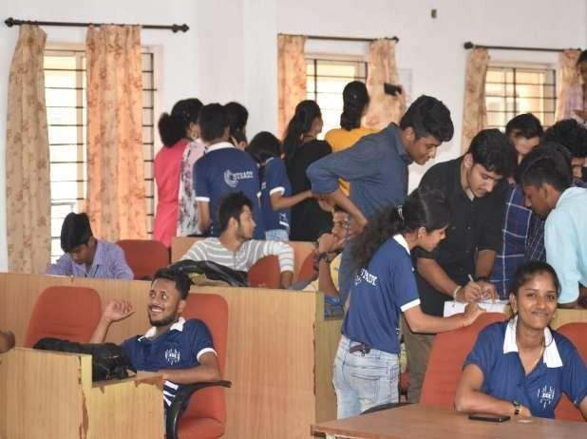 | The most entertaining National level intercollegiate fest comprised of both technical events and cultural programmes, cherishing every participant from various colleges, which made a total of approximately 300 students, with exciting events and programmes.  STEADY organized technical events on the first of the fest. Events included various rounds, step by step accomplishments of task until victory. The prizes were distributed to the place holders on the second day of the fest. The events conducted by STEADY and the winners’ list for the same are as follows.
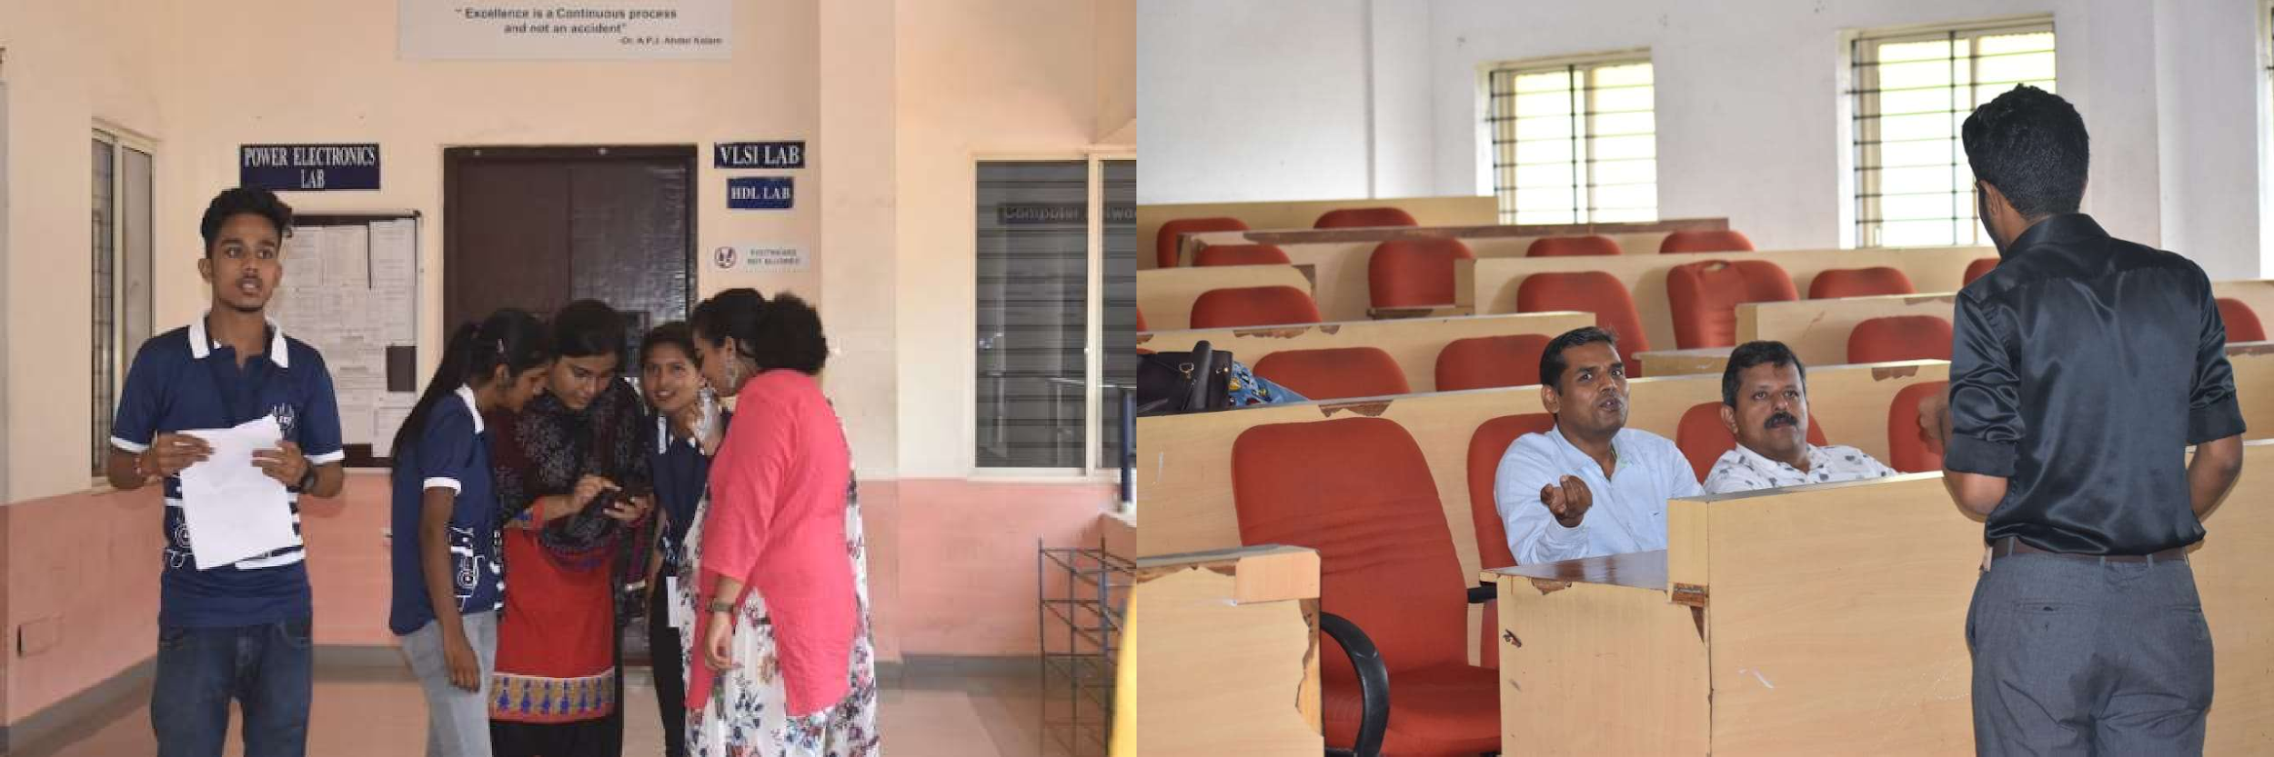

➢ spectaculous 1.0

TEAM SPECTRUM organised their first Mega Event at Srinivas Institute of Technology during ENVISION. 30 teams from colleges from mangalore region participared in the event. Students organised 3 Robotic events RC Racing, Robo Sumo, Line Follower. The winners of the event are as follows.
EVENT | PLACE | TEAM
RC RACING | FIRST | TRIANGLE BETA
 | SECOND | TERROR BULL 1
ROBO SUMO | FIRST | TERROR BULL 2
 | SECOND | AAZAD
LINE FOLLOWER | FIRST | TERROR BULL 2

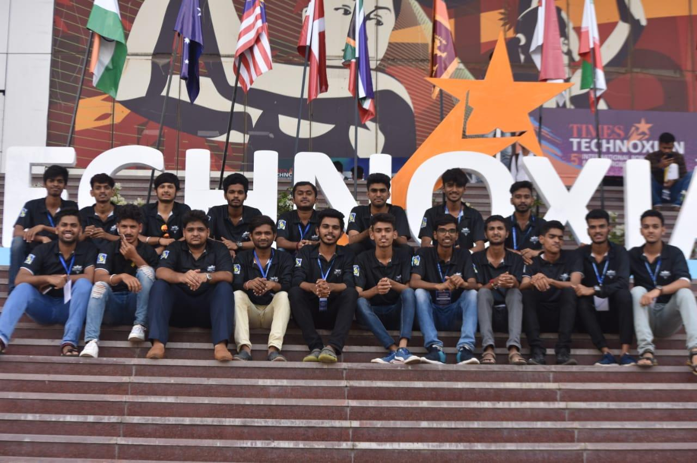

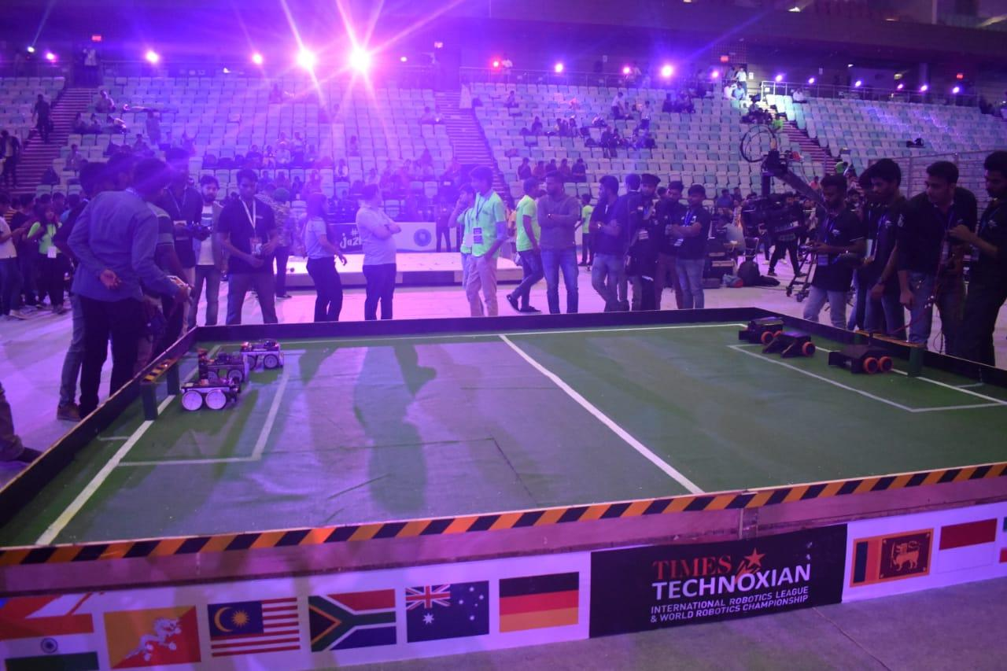

IMPULSIVE TALKS

➢ TECHNICAL TALK BY HRISHIKESH

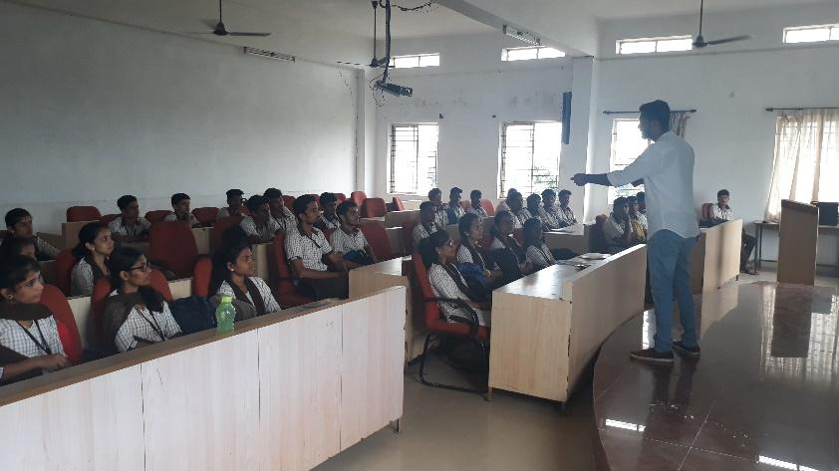
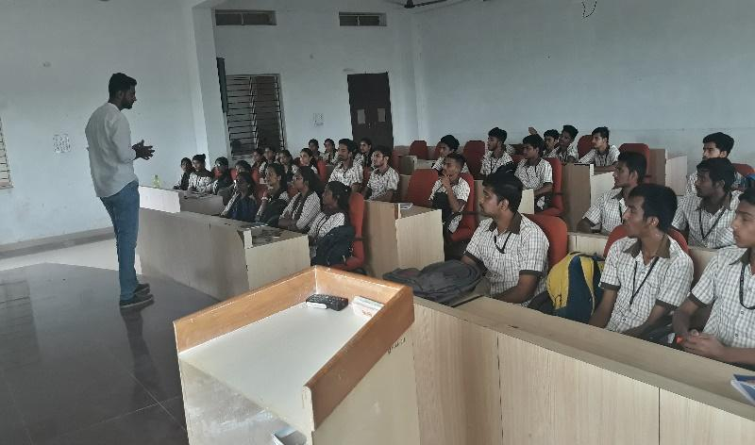

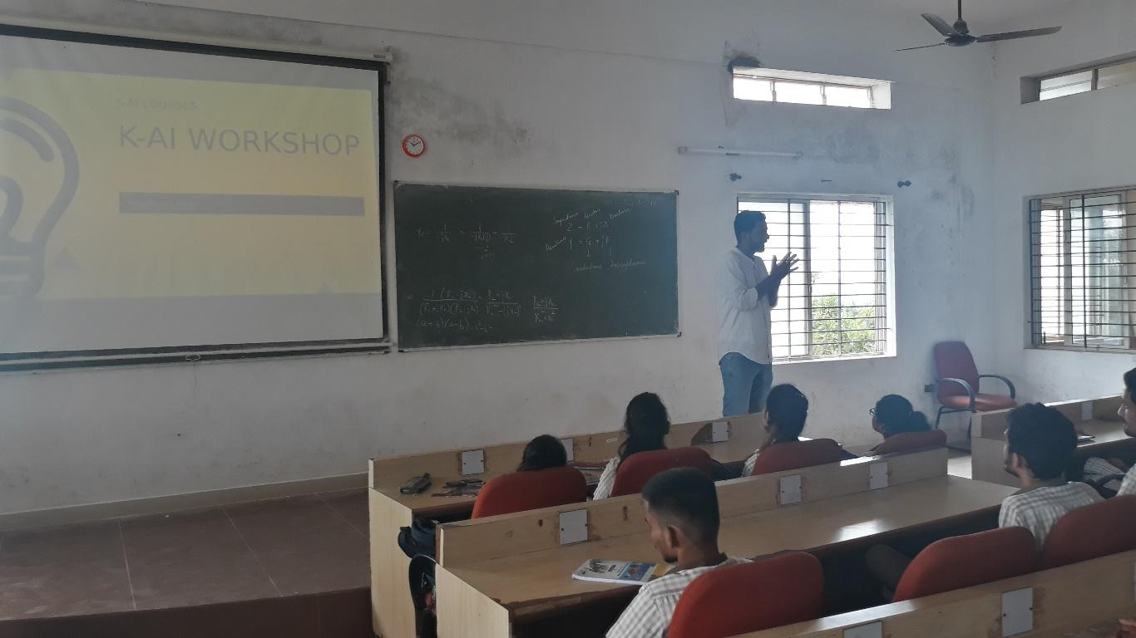

'STEADY' association of SIT ECE Department organised One hour session from 10.00 to 11.00 AM for the 3rd semester ECE students on 18th October 2019 in Room No. 302. Mr. Hrishikesh briefed about Artificial Intelligence and its current market trend in India. Mr. Hrishikesh is a freelance Engineer in Machine learning, Deep learning Neural Networks, Computer vision projects etc. Earlier he was working as Developer in Perfios Solutions Bangalore. Now he is a Educator to train the students with cutting edge technologies like Artificial Intelligence/Machine Learning, 3D Printing etc.

➢ EDP

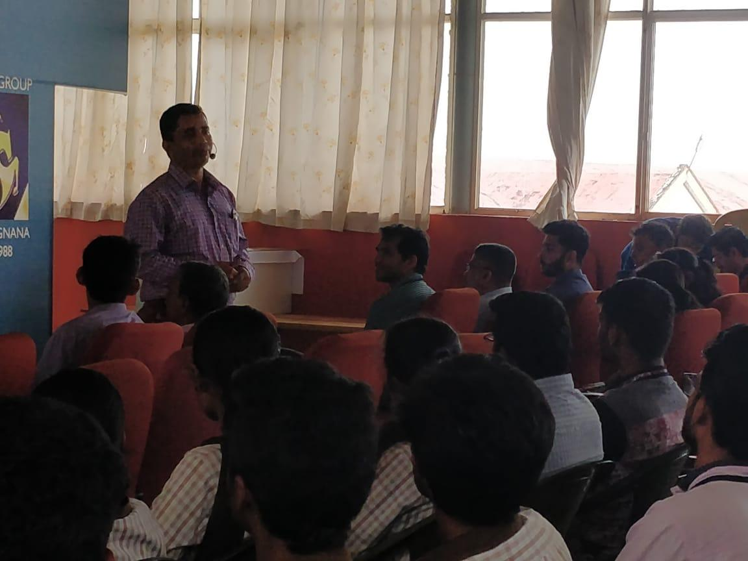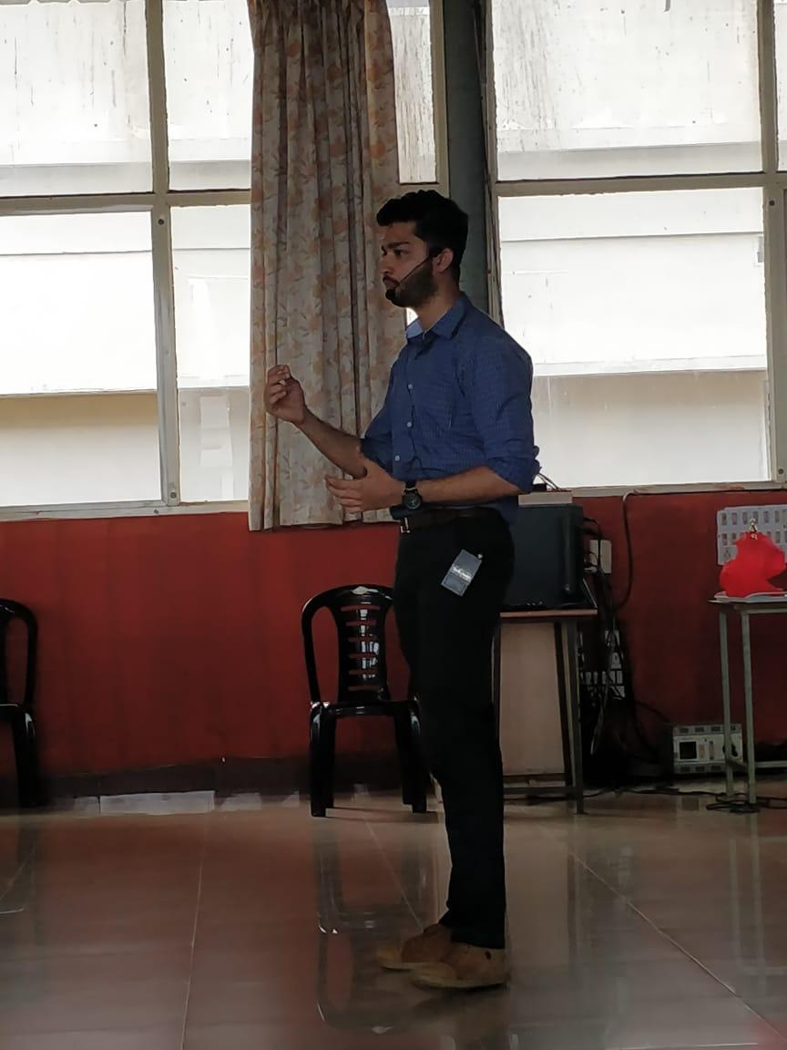

EDP and Incubation Cell of Srinivas Institute of Technology, Mangalore organized “NIDHI - EIR Awareness Programme” is association with Manipal Universal Technology Business Incubator (MUTBI), Manipal on Monday, 30th September, 2019. Dr. Santhosha Rao Assistant General Manager, MUTBI, Manipal spoke on “Manipal Incubators and NIDHI-EIR”. Mr. Mayur Shetty Director, Blackfrog Technologies Pvt. Ltd. Shared “Enterpreneurship journey - experience sharing & interaction” with the students. Dr. Y Shrihari Upadhyaya, CEO, MUTBI spoke on “Enterprise Development”. Three sessions were conducted from 10.30 AM to 12.30 PM. Ninety students from different departments were attended the sessions. Students understood the importance and requirements to start the start-up.

➢ PEER LEARNING SESSIONS ON C PROGRAMMING

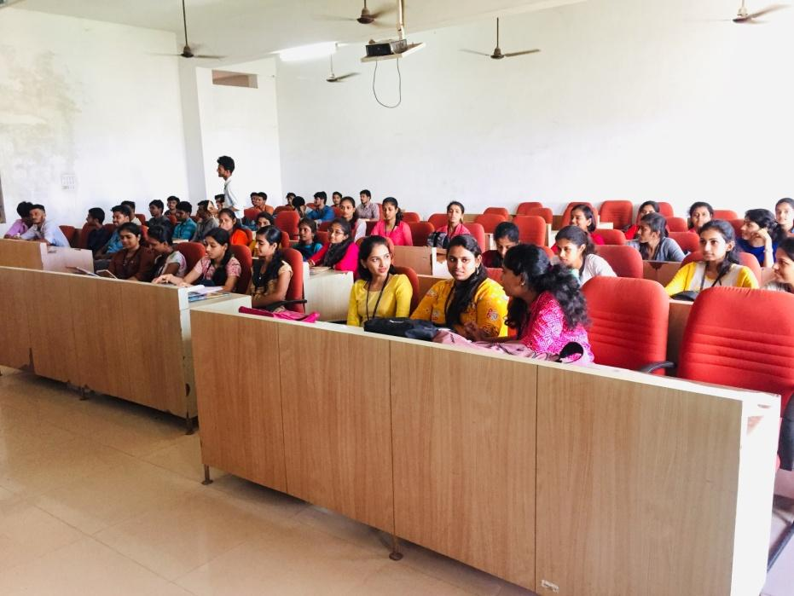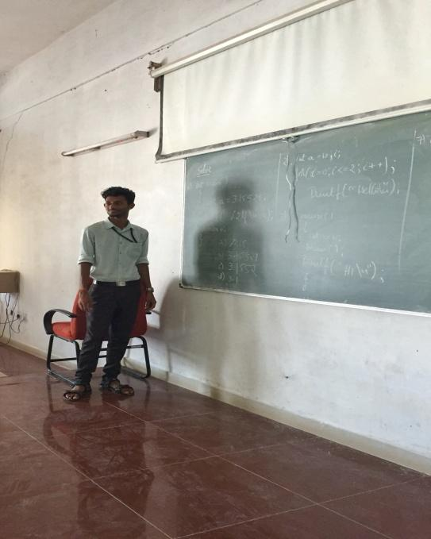

To improve the knowledge on C-programming for the students of 3rd year Electronics and Communication special classes are been conducted on every Tuesday by the final year student Mr.Jagdish. As this will further benifit the students during the placements in upcoming years.

➢ VOCATIONAL EDUCATION TRAINING

Department of Electronics & communication Engineering, SIT Mangalore in Association with IETE student Chapter conducted Two Day Vocational Education Training (VET) on C Programming from 03-10-19 to 04-10-19. Inauguration of the program was held in DSP lab on 03-10-2019 at 9.15 AM. All the students of 5th Semester were actively participated in the program. Mr. Mahesha Padyana
Managing Director, CloudE, Mysuru was the Resource person.

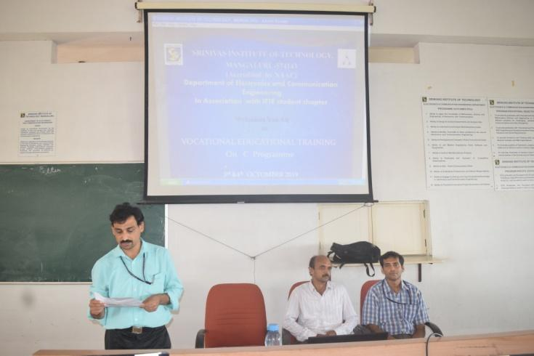

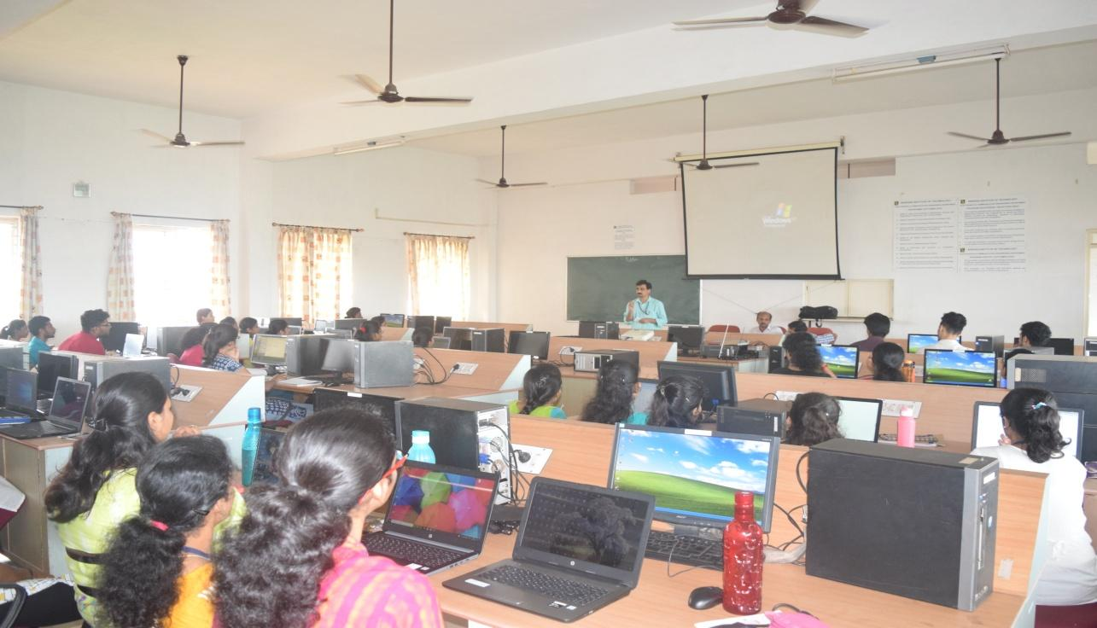

➢ technoxiAN

Students of ECE department ‘TEAM SPECTRUM’ participated in Technoxian 5th WorldRobotics Championship held at Thyagaraj Stadium, NewDelhi. The event was held from 23rd to 25th September 2019. Twenty students from fifth and seventh semester participated in Robo racing and Robo soccer. Team Spectrum bagged 8th Rank in the event with 500+ teams participating from all over the world.

