Srinivas University

Mangalore ‐ India

Atomic Research Centre
On
Cancer detection using Convolutional neural network and Recurrent Neural Network

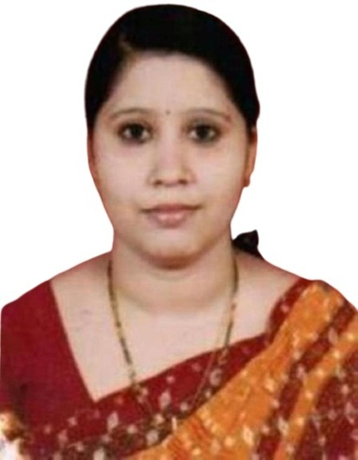

Prof. Divya Naveen
Asst. Professor
Institute of Computer Science and Information Science

- Purpose of ARC : Purpose is to propose an AI model which works as an assistant to doctors. CNN and RNN are used in this model. We are training some of the models under CNN to meet the needs of our project. After this we are using state of algorithm for modeling sequential data which is RNN (Recurrent Neural Network). Also, we are using LSTM for extending the memory of RNN

- Objective of ARC :
- Main objective of this ARC is to generate report for various cancer diagnosis based on the input of CTR images and MRI’s.
- Our AI assistant will generate the required report which has a great accuracy, which is further circulated with many specialists for radiology report with valid signature
- After that, a report is provided to doctors for verification, reducing the amount of time spent on this process. As a result, this project aids in the replacement of manual checking.
- Description on Proposed Research :
The approach used for this research is to designate a certain portion of work for completion. The initial scans are the common ones, like x-rays. The AI helper receives the X-ray scan before receiving it. This AI will enter patient X-rays and send them to computer models. We're interested in mobile net, Densenet, Resnet, and inception because these are common models used for image captioning and processing. CNN (convolution neural network) includes a variety of AI models

- Expected Outcome :
Here Artificial intelligence assistant is used, where there are four popular models namely DenseNet, ResNet, MobileNet, Inception. All the models are trained for the purpose of medical report generation accordingly by giving the input as X-ray image dataset. Here data augmentation is used to increase the accuracy by 30 percent. Finally, the epoch and the loss are estimated through graph of each odel. The website is built where the patient has to enter the credentials and choose the artificial intelligence model. Then the report is generated with the help of image captioning through CNN models.

- List of the Team Members :
Research Coordinator:Prof. Divya Naveen

- List of Working Papers :

(i)Artificial Intelligence for Lung Cancer Diagnosis

- List of related Published Papers in Journals, Proceedings, Book Chapters, Magazines by this Group.
- Review on Brain Tumor detection using Convolutional Neural Network at Srinivas Publications.

Name & Signature of Coordinator with date.
21-06-2022

