Research @
SRINIVAS UNIVERSITY
Research & Innovation Council

Volume-1 Issue-1,
VISION
The Research and Innovation council at Srinivas University strives to create an environment to support researchers who can achieve excellence in deriving dependable solutions to global challenges.
MISSION
To lead, coordinate, and convey multidisciplinary innovative work arrangements in condition, vitality, and data innovation to meet client responsibilities on schedule and at cost. In completing this crucial, Applied Research Center is focused on giving preparing chances to the University's particularly different understudy body under the mentorship of the Center';s globally perceived specialists and researchers.
Samshodhan Vartha


CHANCELLOR’S MESSAGE

My aim is to transform Society through education by setting up academic institutions in dynamic equilibrium with its social, ecological and economic environment striving continuously for excellence in education, research and technological service to the nation.
CA A RAGHAVENDRA RAO

CA A RAGHAVENDRA RAO

PRO-CHANCELLOR’S MESSAGE

We are committed to building a truly exceptional future for our students in an encouraging environment; and work tirelessly towards building skill-sets, knowledge and intellect of our students which imbibe in them curiosity, critical thinking, innovation and professional skills.
DR.A SRINIVAS RAO

Chief Patrons
Shri CA A. Raghavendra Rao
Chancellor
Dr. A. Srinivas Rao
Pro Chancellor
Dr. P. S. Aithal
Vice Chancellor
Dr. Anil Kumar
Registrar
Dr. (Lt Cdr) P.K. Suresh Kumar
Controller of Examination
Mr. Adithya Kumar Maiya
Registrar (Academic and Development)
Dr. Ajay
Registrar Development
Vol-4 Issue -1 2020 Samshodhan Vartha

Editors
Dr. Praveen B.M.
Director
Research & Innovation Council

ABOUT SRINIVAS UNIVERSITY
Srinivas University, Mangalore, is a Private Research University in Mangalore, Karnataka, India established in 2013 by Karnataka State Act. Srinivas University is the flagship of 18 Srinivas Group of Institutions started by A. Shama Rao Foundation, Mangalore, India, a private Charitable Trust founded in 1988 by an eminent Chartered Accountant A. Raghavendra Rao. A. Shama Rao Foundation has started many professional colleges in Mangalore which include Srinivas Institute of Medical Sciences and Research Center, Srinivas Institute of Dental Sciences, Srinivas Institute of Technology, Srinivas College of Pharmacy, Srinivas Institute of Nursing Sciences, A Shama Rao Nursing School, Srinivas Integrated Campus, Srinivas College of Hotel Management, Vijayalakshmi Institute of Hospitality Sciences, Srinivas First Grade College, Srinivas School of Engineering, Srinivas Institute of Management Studies, Srinivas College of Physiotherapy, Srinivas School of Business, Srinivas School of Management, Srinivas College of Education, Srinivas Institute of Social Work
Presently, Srinivas University offers undergraduate, postgraduate, and research courses under 8 Faculties/Colleges with about 60 courses. The University made innovations in designing and starting new super speciality programmes both at UG, and PG level as per present and future industry relevance, innovations in examination system through focus on continuous evaluation and to make it foolproof. The University has established networking with many industries, universities, and education service providers to substantially improve the quality and weightage of the courses and degrees respectively.

Special Achievements
Srinivas University has received the recognition form Department of Scientific and Industrial Research Government of India

International Journal of Management, Technology and Social Sciences (IJMTS) of Srinivas University accepted for Indian citation indexing (ICI) New Delhi.

All the four journals of Srinivas University are registered for Sherpa/Romeo UK for Journal Deposit Policy
- International Journal of Management, Technology and Social Sciences (IJMTS)
- International Journal of Health Sciences and Pharmacy (IJHSP)
- International Journal of Applied Engineering and Management Letters (IJAEML)
- International Journal of Case Studies in Business, IT, and Education (IJCSBE)

CEO Insights has certified as one of the best University for Research in India

Dr P S Aithal achieved the world Rank 1 author as SSRN Elsevier USA indexing and it is fourth Consecutive year

Dr Praveen B M has received R C Shah Memorial National award in chemical sciences from Indian Science Congress, Govt of India

Publications
COLLEGE NAME | PUBLICATIONS
COLLEGE NAME | 2016 | 2017 | 2018 | 2019 | 2020
College of Engineering & Technology | 18 | 44 | 58 | 44 | 21
College of Management & Commerce | 108 | 64 | 71 | 35 | 55
College of Social Science & Humanities | 40 | 32 | 48 | 11 | 03
College of Computer science & Information Science | 29 | 33 | 57 | 28 | 26
College of Physiotherapy |  | 13 | 5 | 17 | 01
College of Allied Health Sciences |  | 11 | 09 | 04 | 07
College of Education | 02 | 01 | 01
Total | 197 | 198 | 249 | 139 | 113
Total | 896

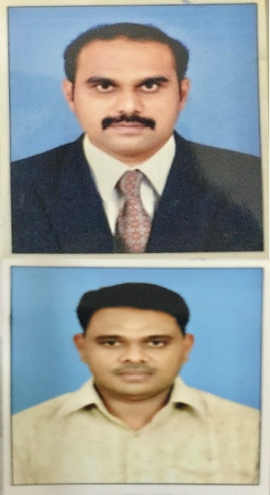
D.Sc., / D.Litt., Awardees
Si No | Name and Reg.No | Title | Photo
01 | Dr.NandhaGopal 19SUDSC001  D.Sc. | HUMAN EYE DETECTION SYSTEM FOR RECOGNIZE EYE DISEASES USING IMAGE PROCESSING | 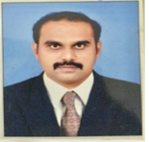
02 | Dr.AnbuKaruppusamy 19SUDSC002  D.Sc. | SOME INVESTIGATIONS ON IMPROVING PERFORMANCE OF FADING CHANNEL IN MANETs | 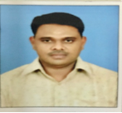
03 | Dr.Zuber Mujeeb Shaikh  19SUDLIT01  D.Litt. | A CRITICAL COMPARATIVE STUDY ON THE NATIONAL ACCREDITATION STANDARD FOR HOSPITALS OF INDIA, AUSTRALIA, DEMARK AND SOUTH AFRICA | 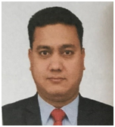
04 | Dr Praveen B M 20SUDSC001  D.Sc. | CORROSION INHIBITION STUDIES BY ELECTRODEPOSITION AND INHIBITORS | 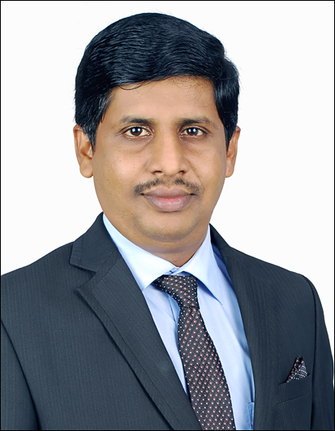
05 | Dr.Suresh R Rao  19SUDSC005  D.Sc. | ULTRASOUD EFFECT ON BRAIN DEVELOPMENT IN MICE | 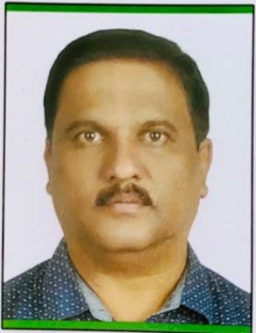

PhD awardees

Si No | Name and Reg. No | Title | Photo
01 | Ajay Kumar SU/PhD/PT(Tr)/2017/1 | A STUDY TO EXAMINE THE INTRA RELIABILITY OF RAPID UPPER LIMB ASSESSMENT(RULA) IN COMPUTER OPERATORS | 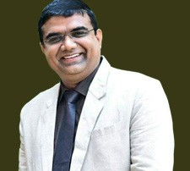  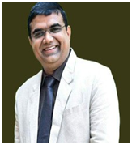
02 | Sonia Delrose Noronha | A STUDY ON WORK LIFE BALANCE AND | 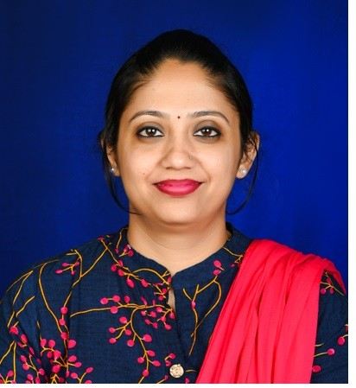
 |  | GLASS CEILING FACED BY WOMEN EMPLOYEES
 | SUPHDMGMT2017/02 | IN EDUCATION SECTOR
Total number of Students in Research Programs
Ph.D. Students
2017 | 16
2018 | 18
2019 (January) | 11
2019  (June) | 50
2020  (January) | 50
2020  (June) | 128
Total | 273
Post Doctoral Students
Post Doctrol Fellow’s | 15
Doctor of Science | 13
Doctor of literature | 3
Total | 31

COLLEGE OF SOCIAL SCIENCES AND HUMANITIES
Research Publications in Journals

- Pradeep, M.D., &Laveena, D’ Mello., (2020). Literature Review on Social Opportunities for the Solar Cold Chain System in India. International Journal of Applied Engineering and Management Letters (IJAEML), 4(1), 131-141. DOI: http://doi.org/10.5281/zenodo.3795740.

- Itagi, Gururaj, &Aithal, P. S. (2020). A Study on the Future of World Leader’s Behaviour towards Global Health after COVID-19. International Journal of Case Studies in Business, IT, and Education (IJCSBE), 4 (1), 127-135. DOI: http://doi.org/10.5281/zenodo.3839765.
- Suvarna, H., D’Souza, S., R.K., M.C. (2020). A Study on Entrepreneurship Education Programme in the Curriculum of Indian Higher Education System. NOLEGEIN Journal of Entrepreneurship Planning, Development and Management, 3(1), 1-5. ISSN: 2581-3900.

Faculty Achievement
- Prof. Pradeep M.D. Completed ‘How to Write and Publish a Scientific Paper (Project-Centered Course) an online Non Credit course authorized by EcolePolytechnique and offered through Coursera.

- Dr.LaveenaD’Mello, successfully completed the Diploma in Professional Studies on “Professional Counselling Diploma” online under the KEY Training Academy.

Attended Sessions as Resource Person
Gururaj Itagi, the Research Scholar, School of Social Sciences & Humanities, Srinivas University, Mangalore, Karnataka, India.
- Session on “Career Planning and Academic Achievement” for Students of class IX & X, at Pompai High School, Kinnigoli, Organized by PrajnaSalaha Kendra. January-2020
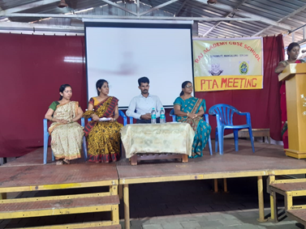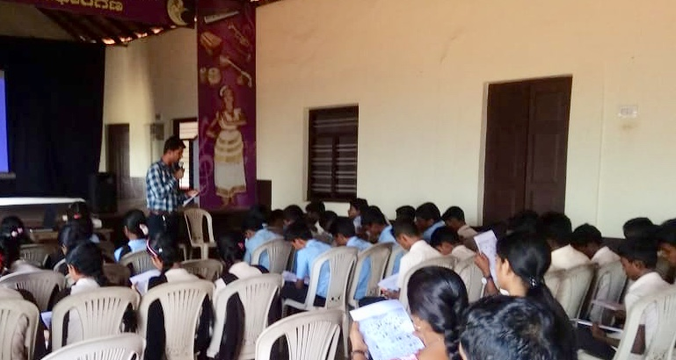

- Session on “School of Values” for Students of Education at Shree Gokarnanatheshwara College of Education, Gandhinagara, Mangaluru- January-2020
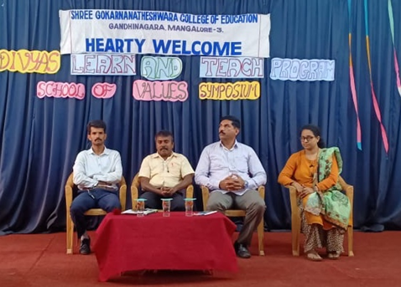
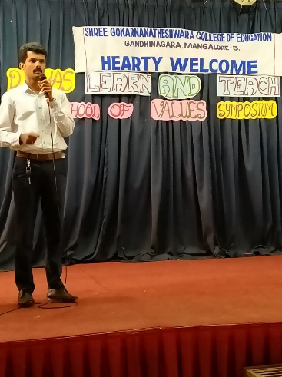
- Session on “Learning Techniques for Academic Achievement” for students of class X, at RV High School, Itagi, Siddapura, UttaraKannada, Karnataka. February-2020

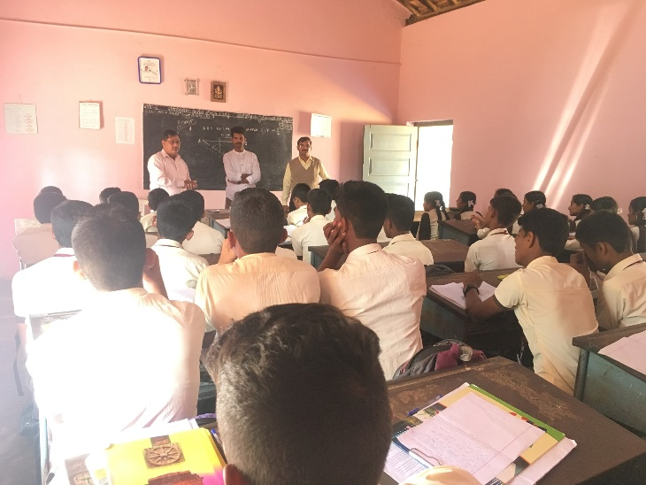
- Session on “Role of Parents in Learning Teaching Process” for Parents and Teachers of Raj Academy CBSC School, Ganjimata, Mangaluru. January-2020

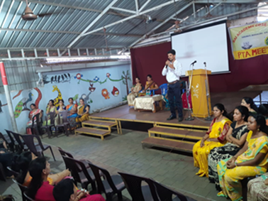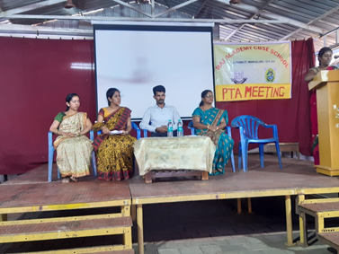

- Workshop for Women on the Topic of “Self Defense and Women Safety” at Munnuru Grama Panchayath Samudhaya Bhavana, KuttaruPadavu, Mangaluru. March-2020

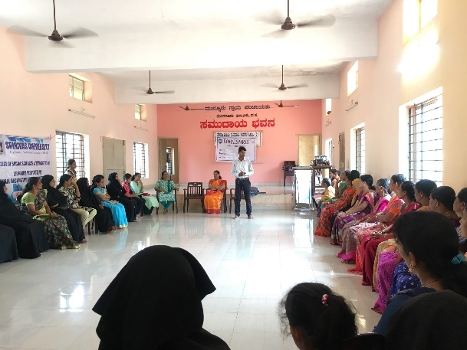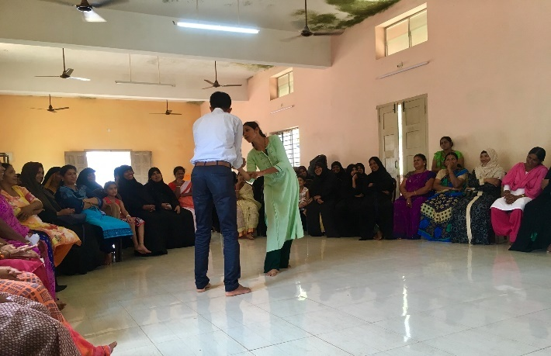

Social Service Programme
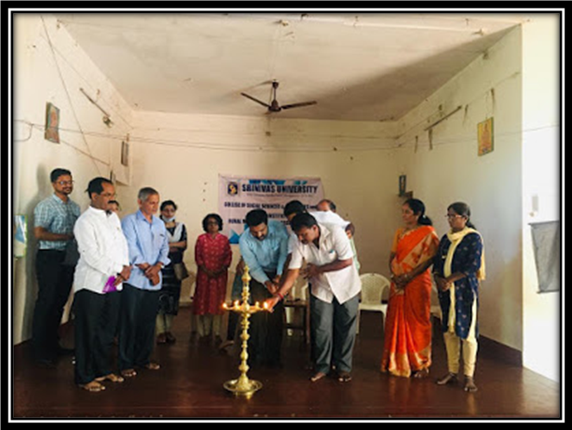
Unnat Bharat Abhiyan, Srinivas University, Srinivas Institute of Rural Reconstruction Agency (SIRRA) in association with Cancer Society, Bengaluru, GramPanchayatCheliaru has organized free Cancer Awareness and Cancer Check-up Camp at SabhaBhavana, Cheliaru Village near Surathkal, Karnataka on 8th March 2020. The Programme was inaugurated by the Mr. Jayanand, President, Gram Panchayat and the representatives of the Cancer Society of India, CODP, Vivekananda Yuvaka Mandala and other local associations were present in the inaugural programme. The Doctors of Father Mullars Charitable Hospital provided free Medical Check Up to the participants and provided generic medicine to the needy. Almost 98 people of Cheliaru Village participated in the programme and got benefitted.

COLLEGE OF PHYSIOTHERAPY
FACULTY ACHIEVEMENTS
Prof. S Rajasekar, Dean, College of physiotherapy, Srinivas University was invited for the 58th Annual IAP Conference (IAPCON 2020) to deliver a talk on “Diagnostic Accuracy of Orthopaedic Special tests- An evidence based approach” held at Mahabalipuram , Chennai on 7th March 2020.
WEBINARS
College of physiotherapy under the banner of Srinivas University has initiated free interactive Webinars from the month of June.
Our series of webinars started with the first webinar session conducted by Dr S Rajasekar , Dean, College of Physiotherapy, SU who enlightened students with the topic “Breathing pattern disorders: musculoskeletal perspective” on 9th June 2020.A total of 186 delegates have participated from different parts of the country and overseas.
The second webinar session was conducted by Dr N. Mageswaran ,Associate Professor , College of physiotherapy who gave an informative session on “Pulmonary hygiene for Covid-19: A Physio Perspective” on 14th June 2020. Around 248 delegates attended the session from different colleges.
Webinar series 3 was conducted by Dr Thrishala Noronha, Associate Professor College of Physiotherapy who shared her insights on the topic “Dizziness Dilemma: differential diagnosis and clinical decision making “on 21st June 2020. Sum total of 165 delegates participated in the session from India and overseas.
The fourth webinar session was conducted by Dr Radhika Gopal, Assistant Professor, College of Physiotherapy who gave ideas on the importance of “Oromotor Care for differently abled children” on 29th June 2020. Total of 180 delegates participated from different Colleges.
After each session feedbacks and suggestions were collected from delegates and verified.

RESEARCH PUBLICATIONS IN JOURNALS
Ilona Gracie De Souza, Pavan Kumar G.(April 2020). Effect of releasing Myofascial chain in patients with patellofemoral pain syndrome- A randomized clinical trial. Int J Cur Res Rev,12(8),5-10. http://dx.doi.org/10.31782/IJCRR.2020.12082
SRINIVAS INSTITUTE OF MANAGEMENT STUDIES & RESEARCH CENTER
[1] Keerthan Raj, &Aithal, P. S. (January 2020). A New Concept of Circular Model of Management for Achieving Sustainable Success and Growth. International Journal of Management, Technology, and Social Sciences (IJMTS), 5(1), 1-17. ISSN :2581-6012,DOI: http://doi.org/10.5281/zenodo.3634224.

[2] Mathew C. D., & Aithal P. S. (February 2020). Retrospective Experiential Learning Theory and its Impact on Countering Social Exclusion in Ecotourism. International Journal of Management, Technology, and Social Sciences (IJMTS), 5(1), 18-23. ISSN :2581-6012,
DOI: http://doi.org/10.5281/zenodo.3660956.

[3] Aithal P. S. &AithalShubhrajyotsna (March 2020). Promoting Faculty and Student-Centered Research and Innovation based Excellence Model to Reimage Universities. International Journal of Management, Technology, and Social Sciences (IJMTS), 5(1), 24-41.
ISSN :2581-6012, DOI: http://doi.org/10.5281/zenodo.3702399.

(4)Mathew, C. D. & Aithal, P. S. (March 2020). Behaviour Modification Model for Improving Social Capital and Fostering Eclectic Theories of Economics. International Journal of Applied Engineering and Management Letters (IJAEML), 4(1), 1-9.ISSN: 2581-7000.
DOI: http://doi.org/10.5281/zenodo.3707038.

(5)Sai Manoj, K. & Aithal, P. S. (February 2020). Data Mining and Machine Learning Techniques for Cyber Security Intrusion Detection. International Journal of Engineering and Advanced Technology (IJEAT), 9(3), 4084-4090. ISSN: 2249 – 8958. DOI :http://doi.org/10.35940/ijeat.C5979.029320. Blue Eyes Intelligence Engineering & Sciences Publication.

(6) Sai Manoj, K. & Aithal, P. S. (March 2020). Blockchain Cyber Security Vulnerabilities and Potential Countermeasures. International Journal of Innovative Technology and Exploring Engineering (IJITEE), 9(5), 1516-1522. ISSN: 2278-3075. Blue Eyes Intelligence Engineering & Sciences Publication. DOI :http://doi.org/10.35940/ijitee.E2170.039520.

(7)Varambally, K.V.M., Sujaya H. & Aithal, P.S. (2020). Innovation in Teaching-Learning Process : An Experiment of Srinivas University.International Journal of Case Studies in Business, IT, and Education (IJCSBE), 4(1), 1-7. ISSN: 2581-6942. DOI: http://doi.org/10.5281/zenodo.3761723.

(8)Suresh Kumar P. M. & Aithal P. S. (Feb. 2020). Time as a Strategic Resource in Management of Organizations. ICTACT Journal on Management Studies, 6(1), 1138-1143. ICT Academy.DOI :http://doi.org/10.21917/ijms.2020.0158.

(9) Aithal, P. S. &ShubhrajyotsnaAithal, (June 2020). Conceptual Analysis on Higher Education Strategies for various Tech-Generations. International Journal of Management, Technology, and Social Sciences (IJMTS), 5(1), 335-351. ISSN :2581-6012,
DOI: http://doi.org/10.5281/zenodo.3940590.

(10) Ganesha, H. R., Aithal, P. S. &Kirubadevi, P. (April 2020). Changes in Consumer Perspective towards Discount at Brick-and-Mortar Stores owing to Emergence of Online Store Format in India. International Journal of Management, Technology, and Social Sciences (IJMTS), 5(1), 43-83.ISSN :2581-6012,DOI: http://doi.org/10.5281/ zenodo.3762937.

(11) Ganesha, H. R., Aithal, P. S. &Kirubadevi, P. (April 2020). Experimental Investigation of Cannibalisation by Introducing a Global Brand Abreast Existing Indian Store Brand. International Journal of Applied Engineering and Management Letters (IJAEML), 4(1), 10-19. ISSN: 2581-7000.Srinivas Publication.DOI: http://doi.org/10.5281/zenodo.3762869.

(12) Ganesha, H. R., Aithal, P. S. &Kirubadevi, P. (April 2020).Short-Term Discounting Frameworks: Insights from Multiple Experiments. International Journal of Case Studies in Business, IT, and Education (IJCSBE), 4(1), 8-22.ISSN: 2581-6942.DOI: http://doi.org/10.5281/zenodo.3762872. 26/04/2020.

(13) Ganesha, H. R., Aithal, P. S. &Kirubadevi, P. (April 2020).Long-Term Discounting Frameworks: Insights from Multiple Experiments. International Journal of Management, Technology, and Social Sciences (IJMTS), 5(1), 84-100. ISSN :2581-6012.
DOI: http://doi.org/10.5281/zenodo.3762939.

(14) Ganesha, H. R., Aithal, P. S. &Kirubadevi, P. (April 2020). Decentralized Discounting Framework: Insights from an Experiment. International Journal of Applied Engineering and Management Letters (IJAEML), 4(1), 20-40.ISSN: 2581-7000.Srinivas Publication.
DOI: http://doi.org/10.5281/zenodo.3762879.

(15) Paul, P. K. & Aithal, P. S. (April 2020).Environment and Studies related to Environmental Sciences: The Overview of Allied Areas. Educational Quest: An Int. J. of Education and Applied Social Science,11(1), 01-05.ISSN: 2230-7311. New Delhi Publishers.

(16) Paul, P. K. & Aithal, P. S. (June 2020).Informatics: Foundation, Nature, Types and Allied areas—An Educational & Analytical Investigation. International Journal of Applied Science and Engineering, 8(1), 01-09. New Delhi Publishers. ISSN :2321-0745.

(17) Paul, P. K., Bhuimali, A.& Aithal, P. S. (2020 March).Environmental Informatics: The Foundation, Allied & Related Branches—Analytical Study. International Journal of Social Sciences, 9(1), 01-07. New Delhi Publishers.

(18) Paul, P. K. & Aithal, P. S., & A. Bhuimali(June 2020). Environmental Informatics and Educational Opportunities in Post Graduate level—Indian Potentialities based on International Scenario. IRA- International Journal of Management & Social Sciences, 16(2), 45-58. ISSN : 2455-2267. DOI :http://dx.doi.org/10.21013/jmss.v16.n2.p2.

(19) Ganesha, H. R., Aithal, P. S. &Kirubadevi, P. (April 2020). Input and Output Driven Sales Personnel Performance Measures: Insights from an Experiment. International Journal of Case Studies in Business, IT, and Education (IJCSBE), 4(1), 23-37. ISSN: 2581-6942. DOI: http://doi.org/10.5281/zenodo.3764555.

(20) Ganesha, H. R., Aithal, P. S. &Kirubadevi, P. (April 2020). Integrated Discounting Framework for Indian Brick-and-Mortar Retailers. International Journal of Management, Technology, and Social Sciences (IJMTS), 5(1), 110-123. ISSN: 2581-6012.DOI :http://doi.org/10.5281/zenodo.3774700

(21) Ganesha, H. R., Aithal, P. S. &Kirubadevi, P. (April 2020). Need-Based Sales Pitch: Insights from an Experiment.International Journal of Case Studies in Business, IT, and Education (IJCSBE), 4(1), 78-86. ISSN: 2581-6942. DOI: http://doi.org/10.5281/ zenodo.3766912.

(22) Ganesha, H. R., Aithal, P. S. &Kirubadevi, P. (April 2020). An Integrated Framework to Derive Optimal Number of Sales Personnel for a Retail Store. International Journal of Applied Engineering and Management Letters (IJAEML), 4(1),41-50.ISSN: 2581-7000.Srinivas Publication. DOI: http://doi.org/10.5281/zenodo.3773886.

(23) Ganesha, H. R., Aithal, P. S. &Kirubadevi, P. (April 2020). Integrated Inventory Management Control Framework. International Journal of Management, Technology, and Social Sciences (IJMTS), 5(1), 147-157.ISSN: 2581-6012.DOI:http://doi.org/10.5281/ zenodo.3775868.

(24) Ganesha, H. R., Aithal, P. S. &Kirubadevi, P. (May 2020). Impact of Store Size Reduction on Overall Store Performance – Insights from an Experiment.International Journal of Case Studies in Business, IT, and Education (IJCSBE), 4(1), 103-111. ISSN: 2581-6942. DOI: http://doi.org/10.5281/zenodo.3822424.

(25) Ganesha, H. R., Aithal, P. S. &Kirubadevi, P. (May 2020). Consumer Affordability in Tier-1, Tier-2 and Tier-3 Cities of India – An Empirical Study. International Journal of Applied Engineering and Management Letters (IJAEML), 4(1), 156-171.ISSN: 2581-7000. DOI: http://doi.org/10.5281/zenodo.3822509.

(26) Keerthan Raj, &Aithal, P. S. (May 2020). The Post COVID-19 World: Efforts Needed to Build Back a More Resilient Society. International Journal of Case Studies in Business, IT, and Education (IJCSBE), 4(1), 88-93. ISSN: 2581-6942. DOI: http://doi.org/10.5281/ zenodo.3783563.

(27) Ganesha, H. R., Aithal, P. S. &Kirubadevi, P. (May 2020). Ideal Store Locations for Indian Retailers – An Empirical Study. International Journal of Management, Technology, and Social Sciences (IJMTS), 5(1), 215-226. ISSN: 2581-6012.DOI: http://doi.org/10.5281/ zenodo.3822528.

(28) Bhuvana R., Madhushree L. M.& P. S. Aithal (May 2020). Blockchain as a Disruptive Technology in Healthcare and Financial Services - A Review based Analysis on Current Implementations. International Journal of Applied Engineering and Management Letters (IJAEML), 4(1), 142-155. ISSN: 2581-7000. DOI: http://doi.org/10.5281/zenodo.3822463.

(29) Bhuvana R., & P. S. Aithal (May 2020). Blockchain based Service: A Case Study on IBM Blockchain Services & Hyperledger Fabric. International Journal of Case Studies in Business, IT, and Education (IJCSBE), 4(1), 94-102. ISSN: 2581-6942. DOI: http://doi.org/10.5281/zenodo.3822411.

(30) Aithal, P. S., &Suresh Kumar P. M. (March 2020). Global Ranking and its Implications in Higher Education. SCHOLEDGE International Journal of Business Policy & Governance, 07(03), 25-47. ISSN 2394-3351, SCHOLEDGE Publishing,
DOI:http://doi.org/10.19085/sijbpg070301.

(31) Sonia Delrose Noronha & P. S. Aithal (May 2020).Work-Life Balance Issues Encountered by Working Women in Higher Education Sector. SCHOLEDGE International Journal of Management & Development, 07, 05, 72-87. ISSN 2394-3378,
DOI: http://doi.org/10.19085/sijmd070501. © SCHOLEDGE Publishing

(32) Aithal, P. S., Richard Grice, & Mike Dillon (June 2020). Solar Cold Chain Optimization Research – An Integrated Multidisciplinary Project Agenda. International Journal of Applied Engineering and Management Letters (IJAEML), 4(1), 226-242. ISSN: 2581-7000.
DOI: http://doi.org/10.5281/zenodo.3901376.

(33) GururajItagi, &Aithal, P. S. (2020). A Study on the Future of World Leader’s Behaviour towards Global Health after COVID-19. International Journal of Case Studies in Business, IT, and Education (IJCSBE), 4(1), 127-135. ISSN: 2581-6942. DOI: http://doi.org/10.5281/zenodo.3839765.

(34) Ganesha, H. R., Aithal, P. S. &Kirubadevi, P. (April 2020). Optimal Category Mix in Multi-Category Retailing – Insights from an Experiment. International Journal of Case Studies in Business, IT, and Education (IJCSBE), 4(1), 112-126. ISSN: 2581-6942. DOI: http://doi.org/10.5281/zenodo.3822483.

(35) Paul, P. K.,Ricardo Saavedra, P. S. Aithal,BashiruAremu,Pappachan Baby (2020). Environmental Informatics: Potentialities in iSchools and Information Science & Technology Programs—An Analysis.International Journal of Management, Technology, and Social Sciences (IJMTS), 5(1), 238-251. ISSN: 2581-6012.DOI: http://doi.org/10.5281/ zenodo.3841661.

(36) Paul,P. K., Aithal,P. S.,Ricardo Saavedra, BashiruAremu,Pappachan Baby (May 2020). Cloud Service Providers: An Analysis of Some Emerging Organizations and Industries. International Journal of Applied Engineering and Management Letters (IJAEML), 4(1), 172-183.ISSN: 2581-7000.DOI: http://doi.org/10.5281/zenodo.3841654.

(37)Bhuvana R., & P. S. Aithal (May 2020). RBI Distributed Ledger Technology and Blockchain - A Future of Decentralized India. International Journal of Management, Technology, and Social Sciences (IJMTS), 5(1), 227-237. ISSN: 2581-6012. DOI: http://doi.org/10.5281/zenodo.3839780.

(38) Paul, P. K.,A. Bhuimali,P. S. Aithal,Tiwary K. S., &RipuRanjanSinha (2020). Environmental Informatics: Educational Opportunities at Bachelors level—International Context and Indian Potentialities. Reviewed on 04/06/2020. International Journal of Applied Engineering and Management Letters (IJAEML), 4(1), 243-256. ISSN: 2581-7000. DOI:http://doi.org/10.5281/zenodo.3911596.

(39) Ganesha, H. R., Aithal, P. S. &Kirubadevi, P. (June 2020). Integrated Marketing Mix Framework for Baby Care Retailing in India.International Journal of Applied Engineering and Management Letters (IJAEML), 4(1), 191-218. ISSN: 2581-7000.
DOI: http://doi.org/10.5281/zenodo.3890290.

(40) Ganesha, H. R. & Aithal, P. S. (2020). Establishing True Lifestyle Brand in India: An Integrated Marketing Mix Framework. International Journal of Management, Technology, and Social Sciences (IJMTS), 5(1), 261-284. ISSN: 2581-6012.
DOI: http://doi.org/10.5281/zenodo.3901365.

(41) Ganesha, H. R. & Aithal, P. S. (June 2020). Rational Distribution Channel Mix for Lifestyle Brands in India – An Empirical Study. International Journal of Case Studies in Business, IT, and Education (IJCSBE), 4(1), 136-154. ISSN: 2581-6942.
DOI: http://doi.org/10.5281/zenodo.3925852.

(42) Ganesha, H. R. & Aithal, P. S. (June 2020). Organizing the Unorganized Lifestyle Retailers in India: An Integrated Framework. International Journal of Applied Engineering and Management Letters (IJAEML), 4(1), 257-278. ISSN: 2581-7000. (30/06/2020). DOI: http://doi.org/10.5281/zenodo.3925840.

(43) Ganesha, H. R. & Aithal, P. S. (June 2020). Measuring the True Potential of Lifestyle Brands in India: A Firm-Level Scale for Existing and Potential Investors - (FL-LBSi). International Journal of Applied Engineering and Management Letters (IJAEML), 4(1), 279-302. ISSN: 2581-7000. (28/06/2020).

(44) ShubhrajyotsnaAithal& P. S. Aithal (August 2020). Cleaning the Environment using Nanotechnology – A Review based Mega-Machine Design. In “Environmental Information Sciences: With aspects on Allied Areas & other emerging interdisciplinary Environmental Concerns” edited by P.K. Paul et al. published by New Delhi Publishers, New Delhi, India, pp. 13-40. ISBN: 978-93-88879-91-0.

(45) Sachin Kumar & P. S. Aithal (June 2020). How Lucrative & Challenging the Boundary less Opportunities for Data Scientists? International Journal of Case Studies in Business, IT, and Education (IJCSBE), 4(1), 223-236. ISSN: 2581-6942. DOI: http://doi.org/10.5281/ zenodo.3966222.

(46) Ganesha, H. R. & Aithal, P. S. (June 2020). Sales Personnel Training – An Integrated Framework for Indian Brick-and-Mortar Retailers? International Journal of Case Studies in Business, IT, and Education (IJCSBE), 4(1), 172-187. ISSN: 2581-6942.
DOI: http://doi.org/10.5281/zenodo.3934429.

(47) Paul, P. K., Aithal, P. S., Bhuimali, A., Tiwary, K. S., & Deka, G. C. (August 2020). Environmental Informatics Vis-à-Vis Big Data Analytics: The Geo-Spatial & Sustainable Solutions. International Journal of Applied Engineering and Management Letters (IJAEML), 4(2), 31-40. ISSN: 2581-7000. DOI: http://doi.org/10.5281/zenodo.3977275.

(48) Ganesha, H. R. & Aithal, P. S. (June 2020). Measuring the True Potential of Lifestyle Brands in India: A Consumer-Level Scale for Existing and Potential Investors (CL-LBSi). International Journal of Case Studies in Business, IT, and Education (IJCSBE), 4(1), 207-222. ISSN: 2581-6942. DOI: http://doi.org/10.5281/zenodo.3940586.

(49) Paul, P. K., Aithal P. S., Sinha, R. R., Ricardo Saavedra, BashiruAremu (June 2020). Agro Informatics with its Various Attributes and Emergence: Emphasizing Potentiality as a Specialization in Agricultural Sciences — A Policy Framework. IRA International Journal of Applied Sciences,14(4), 34-44. (ISSN: 2455-4499), DOI: http://dx.doi.org/ 10.21013/jas.v14.n4.p1.

(50) P. K. Paul, R. R. Sinha, P. S. Aithal, Ricardo Saavedra,&BashiruAremu (June 2020). Agro Informatics with reference to features, functions and emergence as a discipline in Agricultural Sciences—An Analysis. Asian Journal of Information Science and Technology, 10(1), 41-50, ISSN: 2231-6108, © The Research Publication, www.trp.org.in

(51) P.K. Paul, P.S. Aithal, Ricardo Saavedra, BashiruAremu and R.R. Sinha (August 2020). Environmental Informatics and its Features, Functions and Stakeholders: A Comprehensive Overview. In “Environmental Information Sciences: With aspects on Allied Areas & other emerging interdisciplinary Environmental Concerns” edited by P.K. Paul et al. published by New Delhi Publishers, New Delhi, India, pp. 1-12. ISBN: 978-93-88879-91-0.

(52) Paul, P. K. & Aithal, P. S. (2020). Environmental Informatics: Aspects in Society, Economy and Development—A Study. April 2020. Applied Arts Science In IT Age, Edited by Dr. P. K. Paul, New Delhi Publishers, New Delhi, India. Chapter 5, pp. 73-83.
ISBN: 978-93-88879-90-3.

(53) Published a paper on " The post COVID - 19 World: Efforts Needed to Build Back a More Resilient Society" in IJCSB journal in April 2020

- Published a paper Sonia Delrose Noronha1, Dr. P. S Aithal., (2020). Work- Life Balance Issues Encountered by Working Women in Higher Education Sector, SCHOLEDGE International Journal of Management & Development, 7(5). ISSN 2394-3378, 72-87; DOI: 10.19085/sijmd070501on 20.8.2020

- Published an Article on “True Happiness” in Daijiworld Media on 20.07.2020
Suvarna, H., D’Souza, S., R.K., M.C. (2020). A Study on Entrepreneurship Education Programme in the Curriculum of Indian Higher Education System. NOLEGEIN Journal of Entrepreneurship Planning, Development and Management, 3(1), 1-5. ISSN: 2581-3900.

Books :

(56)ENVIRONMENTAL INFORMATION SCIENCES: With aspects on Allied Areas & other emerging interdisciplinary Environmental Concerns, Published by New Delhi Publishers. ISBN: 978-93-88879-91-0. Editors: P.K. Paul, Executive Director, MCIS & Asst. Prof. (CIS), Information Scientist (Offg.), RaiganjUniversty, West Bengal, India; P. S. Aithal, Vice Chancellor, Srinivas University, Mangalore, Karnataka, India; Ricardo Saavedra, (Chair & Director, International Inter University Program) Azteca University, México, North America; BashiruAremu, Vice Chancellor, Crown University Int’l Charted Inc. (CUICI), Argentina, South America; RipuRanjanSinha, Pro Vice Chancellor (Asia), Commonwealth Vocational University, Tonga, Oceania.

Paper Presentation in Conferences
Prof. Amith Menezes
- Presented paper on " Google pay systems " in Government First Grade College, Udupi.
- Presented Paper on “ A Study On Innovation of Green Electric Vehicle in India” , at Government First Grade College Kaup.
- Presented a paper on “A Case Study Approach on IOT with its Implications & Challenges”

COLLEGE OF COMPUTER SCIENCE AND INFORMATION SCIENCE

CONFERENCE/ WEBINAR REPORTS
Five Days Research Methodology Webinar Series
Srinivas University Research and Innovation council organized the Five Days Research Methodology Webinar Series on 1 June 2020 to 5 June 2020 from 6 PM to 8 PM. The Dr. Krishna Prasad K, Associate Professor and Director-College Research Council, College of Computer Science and Information Science, Srinivas University was Webinar Series Convenor and hosted the webinar all five days on behalf of Research and Innovation Council, Srinivas University.
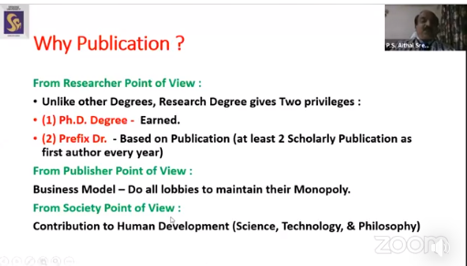
Snapshot of Dr. P. S. Aithal, Vice-Chancellor Srinivas University was Resource Person and handling the session on Publication Strategy: Scholarly Publication and Formatting.

The webinar was inaugurated by Dr. P. S. Aithal, Vice-Chancellor, Srinivas University. Dr. Praveen B. M., Director, Research and Innovation Council, Srinivas University explained about 5 days Webinar. There were a total of 10 sessions of 1 hour duration hosted by eminent well-experienced Professors of Srinivas University. The 10 Sessions related to various topics of Research Methodology are Research Question and Methodology, Research Strategies: How to Select Your Research Topic, Sampling, and Sample Size Determination, Publication Strategy: Scholarly Publication and Formatting, Statistical Methods – Testing of Hypothesis, Plagiarism, Copyright, and Managing Publication in Various Social Research Database like Google Scholar and SSRN, Developing Questionnaire in Management/Social Science Research, Ethics in Social Research, and How to become successful Researcher. Dr. P. S. Aithal, Vice Chancellor, Srinivas University, Mangaluru, Dr. Praveen B M, Director, Research & Innovation Council, Srinivas University, Mangaluru, Dr. Krishna Prasad K, Associate Professor & Director-CRC, College of Computer Science & Information Science Srinivas University, Mangaluru, Prof M. S. Kotian, Research Professor, Srinivas University, Mangaluru, and Dr. Narayana Kayarkatte, Research Professor, Srinivas University, Mangaluru, were five Resource Persons for the Five days Research Methodology webinar. The Webinar Series received an overwhelming response from various parts of India and 500 participants registered.

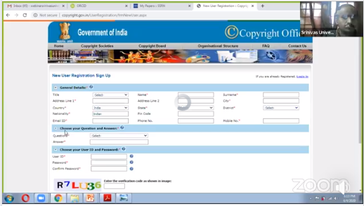
Snapshot of Dr. Krishna Prasad K, Associate Professor & Director-CRC, handling the Session on Copyright.

2.Four days International Virtual Webinar Series on Research Trends in Computer and Information Science
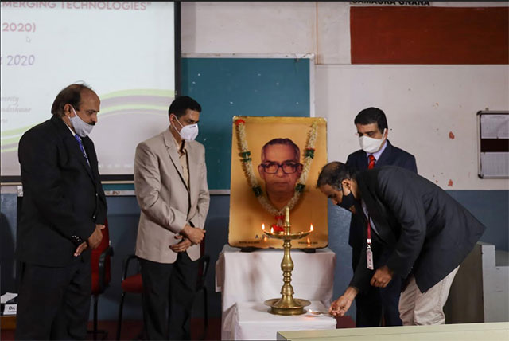

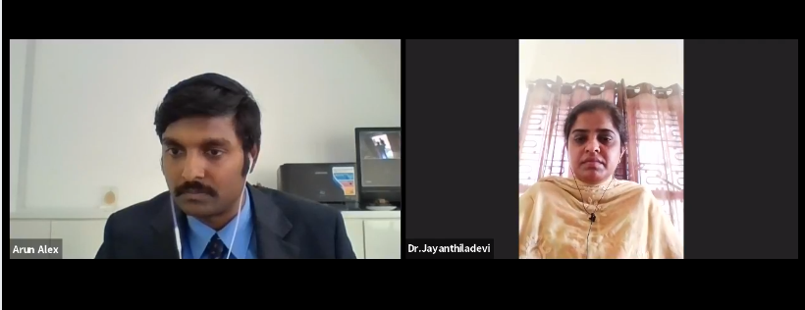

Snapshot of the Live Webinar Sessions

College of Computer Science and Information Science, Srinivas University Pandeshwar, Mangalore, Karnataka, India organized Four days International Virtual Webinar Series on Research Trends in Computer and Information Science from 10th June 2020 to 13th June 2020. Dr. A. Jayanthiladevi, Research Professor and Director-IR & IRC, College of Computer Science and Information Science, Srinivas University and Dr. Krishna Prasad K, Associate Professor and Director-CRC, College of Computer Science and Information Science, Srinivas University were Webinar Conveners. More than 500 participants registered for the Four days International Virtual Webinar Series. Three were 5 sessions every on all four days starting from 10.00 am to 4.00 pm. The details of the 20 Sessions are listed below in Tabular Format.

Session Number | Resource Person | Topic
1 | Dr.PethururajChelliah, Chief Architect and Vice President-Site Reliability Engineering (SRE) Division, Reliance JioInfocomm. Ltd. (RJIL),Sarjapur Road, Bangalore | Research Trends in Digital Technologies and Tools
2 | Arun Ghana Raj, Solution Architect, Qanawat LLC, Dubai,UAE | Cloud Computing Research Trends, Platforms and Tools
3 | Dr.SaravanaBalaji, Assistant Professor, College of Engineering and Computer Science, Lebanese French University, Iraq | Research Trends in Block Chain Technologies
4 | Dr. K.G. Nandha Kumar, Department of Cloud Technology & Data Science  College of Engineering & Technology, Srinivas University | How to do Literature Review in Computer Science
5 | Dr.P.Calduwel Newton, Assistant Professor-Department of Computer Science, Government Arts & Science College, Tiruchirapalli, TamilNadu | How to pursue Research Productively
6 | Dr. Debabrata Singh, Assistant Professor, Department of CSIT, SOA Deemed to be University, Bhubaneswar, Odisha, India | Research Trends in Medical Applications
7 | Dr.Sudeshna Chakraborty, Department of Computer science and Engineering  Sharda University | Research Trends in Big Data Analytics and Hadoop
8 | FHA. Shibly, Senior Lecturer in Information Technology South Eastern University of Sri Lanka | Research Trends in Green computing
9 | Dr.Sujith Jayaprakash, Director and Business Head-New Edge Infotech, Ghana | Research Writing Tools and Techniques
10 | Dr. Krishna Prasad K. Associate Professor & Director-College Research Council, College of Computer Science and Information Science  Srinivas University, Mangaluru, Karnataka, India | Copyright, Patent, and Trademark Registration Process
11  12 | Dr.M.Niranjanamurthy, Assistant Professor-Department of Computer Applications, M.S.Ramaiah Institute of Technology, Bangalore, Karanataka  Dr.Ved P Mishra, Head of Academics-Engineering  Associate professor-Computer science and Engineering, Dubai, UAE | Research Treads in Ecommerce and Digital Marketing tools  Impact on Covid-19 on Computer Science Research Community
13 | Dr.Mohanasundram, Associate Professor-School of Computer Science and Engineering (SCOPE)  VIT University – Vellore, Tamilnadu, India. | How to work with Quartus II Multiplatform Design Environment Software for Computer Science Research
14 | Dr.Prince Mary R, Department of Computer Science, Satyabama University, Chennai, India | Research Trends in Machine Learning and Recommender Systems
15 | Dr.RajeshKhanna, Professor and Head-Department of Information technology, Dr.NGP Arts and Science College, Coimbatore | Research trends in Biological Data Analytics
16 | T. Padma, Professor and Head-Department of Master of Computer Applications, Sona College of Technology | Bio-Inspired Algorithms and Their Applications
17 | Dr. Nismon Rio Robert, Assistant professor-Department of Computer Science, Chirst University, Bangalore, India | Research Trends in Next Generation Networks
18 | Dr.KManikandan , Associate Professor -School of Computer Science & Engineering VIT University, Vellore, Tamilnadu | Simulation Tools forResearch in Networks
19 | Dr.T.P.Latchoumi, Associate Professor,  Department of Computer Science and Engineering,  Vignan's University, Guntur, Andhra Pradesh | Computer Science Research Trends in interdisciplinary Areas
20 | Dr.A.Jayanthiladevi., Professor-Computer Science and Information Science, Director-Industry Relations & International Research Collaborations,  Srinivas University, Karnataka, India | How to Choose Research Topics, Journals for Research Article Publications & Resourceful Writings

The entire International Virtual Webinar Series held in Zoom platform along with the live telecast in YouTube. For all the active participants e-certificate is distributed. The feedback about the session also collected from the participants at the end of the each day.

JOURNAL PUBLICATIONS
Vinayachandra, & Krishna Prasad, K. (2020). Application of IoT in the Development of Intelligent Education System – A Thematic Literature Review. International Journal of Management, Technology, and Social Sciences (IJMTS), 5(1), 124-146.
DOI: http://doi.org/10.5281/zenodo.3775850.

II. JOURNAL PUBLICATIONS
1) Vinayachandra, & Krishna Prasad, K. (2020). Application of IoT in the Development of Intelligent Education System – A Thematic Literature Review. International Journal of Management, Technology, and Social Sciences (IJMTS), 5(1), 124-146.
DOI: http://doi.org/10.5281/zenodo.3775850.
) Rajeshwari, M. &Krishna Prasad, K. (2020). Application of IoT in Analyzing Cognitive Skills of Students-A Systematic Literature Review. International Journal of Management, Technology, and Social Sciences (IJMTS),5(1), 158-184.
DOI:http:http://doi.org/10.5281/zenodo.3821143

3) Geetha Poornima, K. &Krishna Prasad, K. (2020). Application of IoT in Predictive Health Analysis–A Review of Literature. International Journal of Management, Technology, and Social Sciences (IJMTS), 5(1), 185-214. DOI: http://doi.org/10.5281/zenodo.3821147

4) Vinayachandra, K., Geetha Poornima, M., Rajeshwari & Krishna Prasad, K. (2020). Role of Technology in the Development of Smart and Secure Public Voting Systems – a Review of Literatures. International Journal of Management, Technology, and Social Sciences (IJMTS), 5(1), 298-317. DOI: http://doi.org/10.5281/zenodo.3934439

5) Vinayachandra, K., Geetha Poornima, M., Rajeshwari & Krishna Prasad, K. (2020). A Conceptual Framework for the Integrated, Smart and Secure Remote Public Voting System (SSRPVS). International Journal of Management, Technology, and Social Sciences (IJMTS), 5(1), 318-334.DOI: http://doi.org/10.5281/zenodo.3934459

6) Geetha Poornima, K. &Krishna Prasad, K. (2020). Integrated Prediction System for Chronic Disease Diagnosis to Ensure Better Healthcare. International Journal of Health Sciences and Pharmacy (IJHSP), 4(1), 25-39. DOI: http://doi.org/10.5281/zenodo.3773844

7) Rajeshwari, M., &Krishna Prasad, K. (2020).IBM Watson Industry Cognitive Education Methods. International Journal of Case Studies in Business, IT, and Education (IJCSBE), 4(1), 38-50.DOI: http://doi.org/10.5281/zenodo.3766900.

8) Geetha Poornma, K. &Krishna Prasad, K. (2020).Data Analytics Solutions for Transforming Healthcare Information to Quantifiable Knowledge – an Industry Study with Specific Reference to ScienceSoft. International Journal of Case Studies in Business, IT, and Education (IJCSBE), 4(1), 51-63.DOI: http://doi.org/10.5281/zenodo.3766907.

9) Vinayachandra, & Krishna Prasad, K. (2020). IoT Solutions Industry Prospects Analysis with Specific Reference to Mobiloitte Inc. International Journal of Case Studies in Business, IT, and Education (IJCSBE), 4(1), 64-78. DOI: http://doi.org/10.5281/zenodo.3766919.

10) Rajeshwari, M. & Krishna Prasad, K. (2020). A Modified Conceptual Model to Improve Classroom Education with Cognitive Learning. International Journal of Applied Engineering and Management Letters (IJAEML), 4(1), 61-75.DOI:http://doi.org/10.5281/zenodo.3773927.

11) Vinayachandra, &Krishna Prasad, K.(2020).Integrated Intelligent Education System using Adaptive IoT Technology. International Journal of Applied Engineering and Management Letters (IJAEML), 4(1), 76-92.DOI:http://doi.org/10.5281/zenodo.3775328

12) Krishna Prasad, K., Vinayachandra, K., Geetha Poornima, & Rajeshwari, M. (2020).Literature Review of Applications of ICT on Solar Cold Chain. International Journal of Applied Engineering and Management Letters (IJAEML), 4(1), 93-111.
DOI:http://doi.org/10.5281/zenodo.3779806.

13) Krishna Prasad, K., Vinayachandra, K., Geetha Poornima, & Rajeshwari, M. (2020). An Integrated Solution for Solar Cold Chain Portfolio Management using Internet of Things. International Journal of Applied Engineering and Management Letters (IJAEML), 4(1), 112-130.DOI:http://doi.org/10.5281/zenodo.3780575

14) Krishna Prasad K, Vinayachandra, GeethaPoornima K, Rajeshwari M (200), Effect of COVID-19 on Technology Penetration:aPredictive Analysis. Alochana Chakra Journal IX(V), 2949-2967. DOI:10.01011.ACJ.2020.V9I5.00068749.01703

15) Sai Manoj, K. & Aithal, P. S. (February 2020). Data Mining and Machine Learning Techniques for Cyber Security Intrusion Detection.International Journal of Engineering and Advanced Technology (IJEAT), 9(3), 4084-4090. ISSN: 2249 – 8958. DOI :http://doi.org/10.35940/ijeat.C5979.029320. Blue Eyes Intelligence Engineering & Sciences Publication.

16) Sai Manoj, K. & Aithal, P. S. (March 2020). Blockchain Cyber Security Vulnerabilities and Potential Countermeasures.International Journal of Innovative Technology and Exploring Engineering (IJITEE), 9(5), 1516-1522. ISSN: 2278-3075. Blue Eyes Intelligence Engineering & Sciences Publication.

(17) Sachin Kumar & P. S. Aithal (June 2020). How Lucrative & Challenging the Boundary less Opportunities for Data Scientists? International Journal of Case Studies in Business, IT, and Education (IJCSBE), 4(1), 223-236. ISSN: 2581-6942.
DOI: http://doi.org/10.5281/zenodo.3966222.

18) Paul, P. K. & Aithal, P. S. (April 2020). Environment and Studies related to Environmental Sciences: The Overview of Allied Areas. Educational Quest: An Int. J. of Education and Applied Social Science,11(1), 01-05. ISSN: 2230-7311. New Delhi Publishers.

19)Paul, P. K. & Aithal, P. S. (June 2020). Informatics: Foundation, Nature, Types and Allied areas—An Educational & Analytical Investigation. International Journal of Applied Science and Engineering, 8(1), 01-09. New Delhi Publishers.ISSN :2321-0745.
20) Paul, P. K., Bhuimali, A. & Aithal, P. S. (2020 March).Environmental Informatics: The Foundation, Allied & Related Branches—Analytical Study. International Journal of Social Sciences, 9(1), 01-07. New Delhi Publishers.

21) Paul, P. K. & Aithal, P. S., & A. Bhuimali (June 2020). Environmental Informatics and Educational Opportunities in Post Graduate level—Indian Potentialities based on International Scenario. IRA- International Journal of Management & Social Sciences, 16(2), 45-58. ISSN : 2455-2267. DOI :http://dx.doi.org/10.21013/jmss.v16.n2.p2.

22) Paul, P. K., A. Bhuimali,P. S. Aithal,Tiwary K. S., &RipuRanjanSinha (2020). Environmental Informatics: Educational Opportunities at Bachelors level—International Context and Indian Potentialities. Reviewed on 04/06/2020.International Journal of Applied Engineering and Management Letters (IJAEML), 4(1), 243-256. ISSN: 2581-7000. DOI:http://doi.org/10.5281/zenodo.3911596.

23) Paul, P. K., Aithal, P. S., Bhuimali, A., Tiwary, K. S., &Deka, G. C. (August 2020). Environmental Informatics Vis-à-Vis Big Data Analytics: The Geo-Spatial & Sustainable Solutions. International Journal of Applied Engineering and Management Letters (IJAEML), 4(2), 31-40. ISSN: 2581-7000.DOI: http://doi.org/10.5281/zenodo.3977275.

24) Paul1, P. K., Aithal P. S., Sinha, R. R., Ricardo Saavedra, BashiruAremu (June 2020). Agro Informatics with its Various Attributes and Emergence: Emphasizing Potentiality as a Specialization in Agricultural Sciences — A Policy Framework. IRA International Journal of Applied Sciences,14(4), 34-44. (ISSN 2455-4499),
DOI: http://dx.doi.org/10.21013/jas.v14.n4.p1.

25) P. K. Paul, R. R. Sinha, P. S. Aithal, Ricardo Saavedra,&BashiruAremu (June 2020). Agro Informatics with reference to features, functions and emergence as a discipline in Agricultural Sciences—An Analysis.Asian Journal of Information Science and Technology, 10(1), 41-50, ISSN: 2231-6108, © The Research Publication, www.trp.org.in 25/06/2020.

26) P. K. Paul, R. R. Sinha, P. S. Aithal, Ricardo Saavedra,&BashiruAremu (June 2020). Agro Informatics Emphasizing its Potentiality as a Full-Fledged Degree Programs: International Context and Indian Potentialities. Asian Journal of Computer Science and Technology,ISSN: 2249-0701 9(1), 19-26. ISSN: 2249-0701 © The Research Publication, www.trp.org.in

II.BOOKS/BOOK CHAPTER PUBLICATIONS
1) Krishna Prasad K (2020). Vedic Mathematics Made Basic Mathematical Calculations Easy and at our Finger Tips. April 2020. Applied Arts Science In IT Age, Edited by Dr. P. K. Paul, New Delhi Publishers, New Delhi, India. Chapter 5, pp. 51-72.ISBN: 978-93-88879-90-3.
(2) Krishna Prasad K (August 2020). Eco-Friendly Clean Technologies Challenges and Opportunities- A Systematic Study. In “Environmental Information Sciences: With aspects on Allied Areas & other emerging interdisciplinary Environmental Concerns” edited by P.K. Paul et al. published by New Delhi Publishers, New Delhi, India, pp. 41-74. ISBN: 978-93-88879-91-0.

3) Vinayachandra, Geetha Poornima K and Rajeshwari M (August 2020). Electronic Recycling and Disposal-a systematics study.In “Environmental Information Sciences: With aspects on Allied Areas & other emerging interdisciplinary Environmental Concerns” edited by P.K. Paul et al. published by New Delhi Publishers, New Delhi, India, pp. 125-158. ISBN: 978-93-88879-91-0.

(4) P.K. Paul, P. S. Aithal, Ricardo Saavedra, BashiruAremu and R.R. Sinha (August 2020). Environmental Informatics and its Features, Functions and Stakeholders: A Comprehensive Overview. In “Environmental Information Sciences: With aspects on Allied Areas & other emerging interdisciplinary Environmental Concerns” edited by P.K. Paul et al. published by New Delhi Publishers, New Delhi, India, pp. 1-12. ISBN: 978-93-88879-91-0.

5) Paul, P. K. & Aithal, P. S. (2020).Environmental Informatics: Aspects in Society, Economy and Development—A Study. April 2020. Applied Arts Science In IT Age, Edited by Dr. P. K. Paul, New Delhi Publishers, New Delhi, India. Chapter 5, pp. 73-83.
ISBN: 978-93-88879-90-3.

IV.COPYRIGHT/PATENT REGISTRATION
1. Copyright Registration by Copyright Office, Government of India (by Dr. P. S. Aithal)

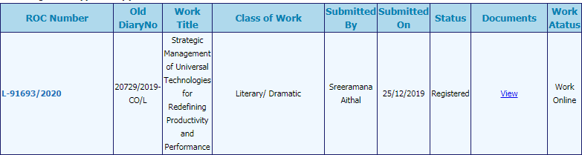

2. Copyright Registration by Copyright Office, Government of India (by Dr.Krishna Prasad K)



3. Patent Registered by Dr. Krishna Prasad K

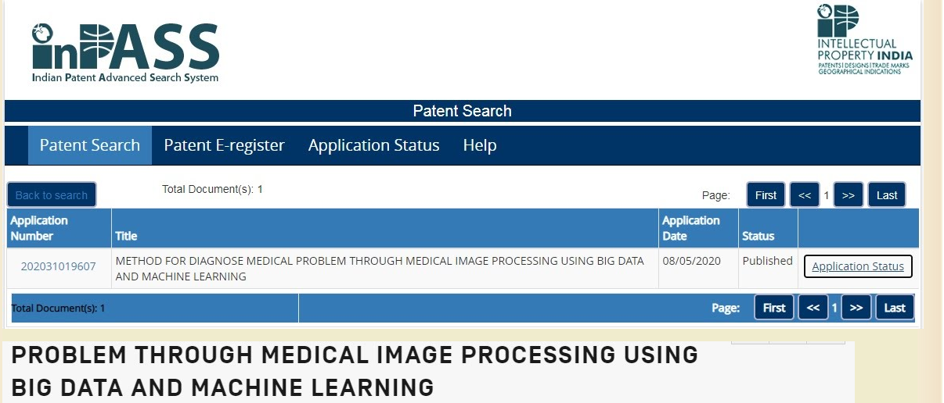

College fo Engineering and Technology
List of Publications from Jan to June 2020:
- Bhat, D.K. and Shenoy, S.U. (2020).Mg/Ca Doping Ameliorates the Thermoelectrics Properties of GeTe: Influence of Electronic Structure Engineering. J. Alloys Compd., 834, 155989. DOI: https://doi.org/10.1016/j.jallcom.2020.155989.
- Bhat, D.K. and Shenoy, S.U. (2020).SnTe Thermoelectrics: Dual Step Approach for Enhanced
Performance. J. Alloys Compd., 834, 155181. DOI: https://doi.org/10.1016/j.jallcom.2020.155181.
- Shenoy, S.U. and Bhat, D.K. (2020).Enhanced Thermoelectric Properties of Vanadium Doped SrTiO₃: A Resonant Dopant Approach. J. Alloys Compd., 832, 154958. DOI: https://doi.org/10.1016/j.jallcom.2020.154958.
- Bantawal, H., Shenoy, S.U. and Bhat, D.K. (2020). Vanadium-Doped SrTiO₃ Nanocubes: Insight into Role of Vanadium in Improving the Photocatalytic Activity. Appl. Surf. Sci., 513, 145858. DOI: https://doi.org/10.1016/j.apsusc.2020.145858.
- Sethi, M., Shenoy, S.U.,Selvakumar, M. and Bhat, D.K. (2020).Facile Solvothermal Synthesis of NiFe₂O₄ Nanoparticles for High Performance Supercapacitor Applications.Front. Mater. Sci.,14 (2), 120 – 132.DOI:10.1007/s11706-020-0499-3.
- Sethi, M., Shenoy, S.U. and Bhat, D.K. (2020).Porous Graphene-NiCo₂O₄ Nanorod Hybrid Composite as High Performance Supercapacitor Electrode Material. New J. Chem., 44, 4033 – 4041. DOI: https://doi.org/10.1039/C9NJ05725K.
- Ms Shilpa S, “Finite Element Analysis of Cylindrical and Spherical Concrete Vaults”, International Journal for Modern Trends in Science and Technology, Volume 6, Issue 6, 2020.
- Ms Shilpa S, “Blast Analysis of Infilled steel Tube Columns”, International Journal for Modern Trends in Science and Technology, Volume 6, Issue 6, 2020.
- N. M. Mallikarjuna · J. Keshavayya · B. M. Prasanna B. M. Praveen H. C. Tandon (2020)
Synthesis, Characterization, and Anti-corrosion Behavior of Novel Mono Azo Dyes
Derived from 4,5,6,7-Tetrahydro-1,3-benzothiazole for Mild Steel in Acid Solution
Journal of Bio- and Tribo-Corrosion (2020) 6:9 https://doi.org/10.1007/s40735-019-0306-9

- D. Rashmi . G. P. Pavithra . B. M. Praveen . Deepa Devapal
Development of Nanocrystalline Multilayer Ni-Fe alloy coatings: Characterization and its Corrosion behavior at elevated temperature., Bulletin of Materials Science, 43 ,131 (2020) . https://link.springer.com/article/10.1007/s12034-020-02087-6

- D. Rashmi . G. P. Pavithra . B. M. Praveen . Deepa Devapal . K. O. Nayana . G. Nagaraju (2020) Electrodeposition of Zn-Ni monolithic coatings, characterization and corrosion analysis., Journal of Failure Analysis and Prevention. 20, 513–522 (2020). https://doi.org/10.1007/s11668-020-00848-3

- Pavitra V; Udayabhanu Udayabhanu; Harini R; Viswanatha R.; Praveen B.M.; Nagaraju G, (2020) Sonochemical synthesis of SnO2-CuO nanocomposite: Diverse applications on Li-ion battery, Electrochemical sensing and Photocatalytic activity. Journal of Materials Science: Materials in Electronics. DOI: 10.1007/s10854-020-03408-5
- ., D. Rashmi · G. P. Pavithra· B. M. Praveen · Deepa Devapal · K. O. Nayana,
Sudheendra P. Hebbar Characterization and Corrosion Analysis of electrodeposited Nanostructured Zn-Fe Alloy Coatings", has been accepted for publication in. Journal of Bio- and Tribo-Corrosion
https://doi.org/10.1007/s40735-020-00380-9

- Narayana Hebbar . B. M. Praveen . B. M. Prasanna . P. Vishwanath ( 2020) Electrochemical and Adsorption Studies of 4-Chloro,8-(Trifluoromethyl)Quinoline (CTQ) for Mild Steel in Acidic Medium
https://doi.org/10.1007/s11668-020-00944-4
15. Aithal P. S. & Aithal Shubhrajyotsna (March 2020). Promoting Faculty and Student-Centered Research and Innovation based Excellence Model to Reimage Universities. International Journal of Management, Technology, and Social Sciences (IJMTS), 5(1), 24-41. ISSN : 2581-6012, DOI: http://doi.org/10.5281/zenodo.3702399.
16. Aithal, P. S. & Shubhrajyotsna Aithal, (June 2020). Conceptual Analysis on Higher Education Strategies for various Tech-Generations. International Journal of Management, Technology, and Social Sciences (IJMTS), 5(1), 335-351. ISSN : 2581-6012,
DOI: http://doi.org/10.5281/zenodo.3940590.

17. Aithal P. S. & Shubhrajyotsna Aithal (July 2020). Importance of Arts & Design in Liberal education STEAM model of Higher Education. Chapter I, pp. 1-24.
Applied Arts Science in IT Age, Edited by Dr. P. K. Paul, New Delhi Publishers, New Delhi, India. ISBN: 978-93-88879-90-3.
18. Shubhrajyotsna Aithal & P. S. Aithal (2020). Cleaning the Environment using Nanotechnology – A Review based Mega-Machine Design. In “Environmental Information Sciences: With aspects on Allied Areas & other emerging interdisciplinary Environmental Concerns” edited by P.K. Paul et al. published by New Delhi Publishers, New Delhi, India, pp. 13-40. ISBN: 978-93-88879-91-0.
19. Aithal, P. S. & Shubhrajyotsna Aithal (June 2020). Information Communication and Computation Technology (ICCT) and its Contribution to Universal Technology for Societal Transformation. ICCT Book of Dr. Paul. In Information Communication and Computation Technologies – The Pillar of Transformation, PP: 1-23. New Delhi Publishers, India.
20. P. S. Aithal & Shubhrajyotsna Aithal (July 2020). Opportunities & Challenges for Green and Eco-friendly Nanotechnologies in 21st Century. Submitted to Book of Editors : Yashwant V Pathak & Govindan Parayil, USF, USA, ypathak1@usf.edu
Submitted on 26/07/2020. DOI:
21. Aithal, P. S. & Shubhrajyotsna Aithal (August 2020). Analysis of the Indian National Education Policy 2020 towards Achieving its Objectives. International Journal of Management, Technology, and Social Sciences (IJMTS), 5(2), 19-41. ISSN: 2581-6012. DOI: http://doi.org/10.5281/zenodo.3988767

College of Allied Health Sceinces

- Dias Edwin (2020) An Overview of Diagnosis Neonatal Sepsis with Antimicrobial Management International Journal of Health sciences and Pharmacy (IJHSP) Vol.4,No.1, DOI: http://doi.org/10.5281/zenodo.3766836.
- Dias Edwin. (2020) A review on common antihelmintics in child hood , DOI :http://10.33552/GJPNC.2020.02.000533
- Dias Edwin (2020) An uncommon presentation double H type of tracheoesophageal Fistula, DOI: http://10.15406/ipcb.2020.06.00193
- . Dias Edwin (2020) Stratergies for stopping a pandemic eBMJ, DOI : http://doi.org/10.1136/bmj.m2376
- A study of anatomical variation of external jugular vein, World Journal of Advanced Research and Reviews, Suresh R Rao and T Ramesh Rao 2020, 07(01), 197-201, Article DOI: https://doi.org/10.30574/wjarr.2020.7.1.0252

