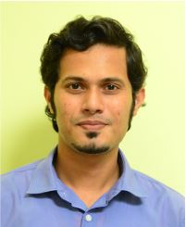
Name : Dr. Ajay Kaushik Noronha
Department : MBA
College : Institute of Engineering &Technology
Contact Details : 7760552614

Educational Details:
- UG : BE (Mechanical Engineering)
- PG : M-Tech (Engineering Management)
- Ph.D. : Lean Six Sigma

Teaching Experience : 1 year
Research Experience :4 years
Research Details:
Implementation of Lean Six Sigma
- Research Area : Interdisciplinary
- Funding sanctioned : JRF fellowship
- Publications : 9
- Conference/Workshops attended: 6
- Any other details : Currently pursuing PDF in Lean Six Sigma from Srinivas University

