CHIEF PATRON
Sri CA A. Raghavendra Rao
Chancellor, Srinivas University

PATRON
Dr. A. Srinivas Rao
Pro Chancellor, Srinivas University

CONFERENCE DIRECTOR
Dr. P.S. Aithal
Vice Chancellor, Srinivas University

CONFERENCE CONVENER
Dr. Jayashree K
Dean, College of Education Srinivas University

CONFERENCE CO-ODINATOR

Mr. Padmanabha C H
Asst. Professor, College of Education Srinivas University

CONFERENCE ORGANIZING COMMITTE MEMBERS
Dr. Vijayalakshmi Naik, Asst. Professor Mrs. Supriya K.P, Physical Director Mrs. Reshma M.Y, Asst. Professor Mrs. Seema P.V, Lecturer
Mrs. Shakeela K, Lecturer

NATIONAL CONFERENCE ON “INNOVATIVE TECHNIQUES OF SCHOOL EDUCATION AND TEACHER EDUCATION FOR 21ST CENTURY ”
December 14, 2019
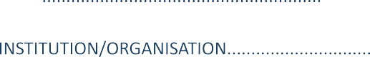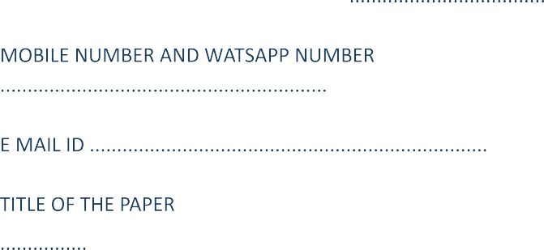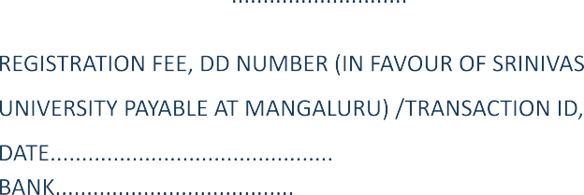REGISTRATION FORM

SRINIVAS UNIVERSITY
COLLEGE OF EDUCATION
City Campus, Pandeshwara, Mangalore-575001 Telephone No.0824-4258493 Mobile No.9845668083
The National Conference on

INNOVATIVE TECHNIQUES OF SCHOOL EDUCATION AND TEACHER EDUCATION FOR 21ST CENTURY

On 14th DECEMBER 2019
Organized by
Internal Quality Assurance Cell (IQAC)

To

VENUE SRINIVAS UNNIVERSITY
COLLEGE OF EDUCATION, PANDESHWAR,MANGALURU

ABOUT SRINIVAS UNIVERSITY
Srinivas University, Mangalore, is a Private Research University in Mangalore, Karnataka, India established in 2013 by Karnataka State Act and approved by UGC. Srinivas University is the ﬂagship of 18 Srinivas Group of Institutions started by A. Shama Rao Foundation, Mangalore, India, a private Charitable Trust founded in 1988 by an Eminent Chartered Accountant A. Raghavendra Rao.
A. Shama Rao Foundation has started many professional colleges in Mangalore which include Srinivas Institute of Medical Sciences and Research Center, Srinivas Institute of Dental Sciences, Srinivas Institute of Technology, Srinivas College of Pharmacy, Srinivas Institute of Nursing Sciences, A Shama Rao Nursing School, Srinivas Integrated Campus, Srinivas College of Hotel Management, Vijayalakshmi Institute of Hospitality Sciences, Srinivas First Grade College, Srinivas School of Engineering, Srinivas Institute of Management Studies, Srinivas College of Physiotherapy, Srinivas School of Business, Srinivas School of Management, Srinivas College of Education, Srinivas Institute of Social Work.

ABOUT COLLEGE OF EDUCATION
College of Education afﬁliated to Srinivas University has been established 2017-18 with vision of transforming an individual for the betterment of himself and the society at large. It has 2year B.Ed. Degree programme approved by NCTE and Government of Karnataka. The College has aim of developing dynamic teachers who can take up the responsibility of moulding the students and their life to become responsible citizens. The college imparts innovative and qualitative professional education to the aspiring teachers through modern, sophisticated techniques of teaching yet without losing the ﬂavour of traditional teaching methodology.

ABOUT THE CONFERENCE
The modern school education and teacher education are tremendously expanding due to globalisation, ICT and e- learning, blended learning, social, political, economic and educational uplift. Besides others, the innovation and integration are two essential components of education.
Teacher education scenario also changes according to new educational policy and global international perspectives. To provide platform of sharing, deliberation and contribution towards need and improvement of education system of India, to focus the innovation and integration required for changing demands of school system.

SUGGESTED SUB THEMES:
- 21st century skills for education
- Innovation in Pedagogy
- Education for Skill development
- Subject speciﬁc Education
- Perspectives of education
- Education policy and Implementation
- Digital Literacy
- Roles of stakeholders
- Inclusive education
- Gender sensitisation in Education
SUBMISSION OF PAPER:
- Thematic or Research based papers or poster presentation are invited from Academicians working at Schools, Colleges and Universities in any Disciplines. Research Scholars, Policy Makers, Other Interested Groups and Student Teachers can participate and Present the paper in the Conference.
- Conference paper should be Original, Unpublished andadhere to the Conference Theme. APA Style should be strictly followed in citations.
- Last Date for Submitting Full paper along with Abstract on or before 30.11.2019
- Email ID: principaledu@srinivasgroup.com
- Selected papers shall be published in UGC & ISSN approved peer reviewed refereed Journal.
- Word Speciﬁcation: Abstract 300 words and for full length paper 1500-2000 words.
- Text Speciﬁcation English: Times New Roman, 12 font size,
1.5 line spacing, justiﬁed; Heading 14pt, Times New Roman and Bold Spaced, Sub Headings 12pt, Times New Roman and Bold Spaced.
- Kannada: Baraha Direct font size 14, 1.5 line spacing.

REGISTRATION FEE RS.500/-
- Registration fee includes: Conference Kit, Participation Certiﬁcate and hospitality during the conference.
- The registration fee is non-refundable.
- It the paper is authored by more than one author, any one author has to present the paper. Certiﬁcate will be issued to only the participant who has attended and presented the paper.
- No TA/DA will be provided.
- The registration from duly ﬁlled in all respects along with the prescribed fee is to be sent to the organizing Secretary.
- Registration is based on ﬁrst come ﬁrst served basis only.

IMPORTANT DATES

Last Date for Submission of full paper with abstract 30th November 2019
Last date of Acceptance of the paper 5th December 2019 Date of Conference 14th December 2019
PAYMENT DETAILS
Account name: SRINIVAS UNIVERSITY Account number: 60221844775
Bank name: Bank of Maharashtra, Mangalore branch
IFSC Code: MAHB0000381

ADDRESS FOR COMMUNICATION:
Mr. Padmanabha C.H,
Asst. Professor, College of Education Srinivas University
City Campus, Pandeshwara, Mangalore-575001 Telephone No.0824-4258493
Mobile No.7619581864, 9449167206

