SRINIVAS UNIVERSITY  Private University Established by Karnataka Govt. ACT No.42 of 2013.  Srinivas Nagar, Mukka – 574 146 Surathkal, Mangalore  International Conference on “Recent Trends in Nanotechnology”  18th & 19th October 2019  Registration Form  Name of the Participant: …………………………………………….  Department: ……………………………………………………………….  Designation: ………………………………………………………………..  Institution/Industry: …………………………………………………...  Address: ………………………………………………........................  ……………………………………………………………………………………..  …………………………………………………………………………………….. Mobile:  E-Mail:  Signature Of the Applicant Approving Authority  Convener  Mr. AMRUTH C H  Assistant Professor, Mechanical Engineering Department | Chief-in-Patrons  Shri CA A. RAGHAVENDRA RAO  Chancellor  Dr. A. SRINIVAS RAO  Pro Chancellor  Patrons  Dr. P S AITHAL Vice Chancellor  Dr. ANIL KUMAR Registrar  Dr. SHRINIVASA MAYYA D Registrar (Evaluation)  Dr. AJAY Registrar (Development)  Dr. SHREEPRAKASH B Dean  Dr. PRAVEEN B M Director - Research & Innovation Council  Advisory Committee  Dr.Kalappa PRASHANTHA, PhD DSc  Professor and Dean  (International Scientific Cooperation)  Department of Polymers and Composites Technology & Mechanical Engineering,  Institut Mines-Télécom 941, rue Charles Bourseul B.P.10838-59508 Douai Cedex, FRANCE  Dr.Omid Akbarzadeh  Nanotechnology & Catalysis Research Centre (NANOCAT), Level 3, Block A, Institute of Advanced Studies (IAS), University of Malaya, 50603  Kuala Lumpur, Malaysia  Programme Committee  Dr. RAMAKRISHNA HEGDE Head, Dept. of Civil Engg.  Prof. BAGLODI R KISHORE Head, Dept. of Computer Science Engg.  Dr. SUMA BHAT Head, Dept. of Mechanical Engg.  Prof. NAGRAJA N S Head, Dept. of Electronics & Communication Engg.  Dr. SANTHOSH D SHENOY Head, Dept. of Physics  Prof. ROHAN DAVID FERNANDEZ Head, Dept. of Humanities | SRINIVAS UNIVERSITY  Private University Established by Karnataka Govt. ACT No.42 of 2013.  International Conference on “Recent Trends in Nanotechnology”  18th & 19th October 2019  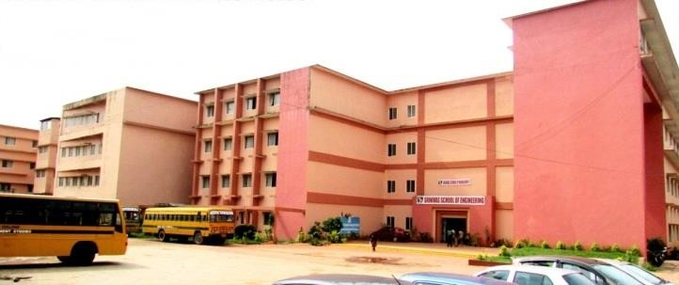  Organised by  College of Engineering & Technology  Supported by  Department of Research & Innovation Council
Srinivas Nagar, Mukka– 574 146, Surathkal,
Mangalore, Phone: 0824-2477456 Web: www.srinivasuniversity.edu.in, Email: info@srinivasuniversity.edu.in

