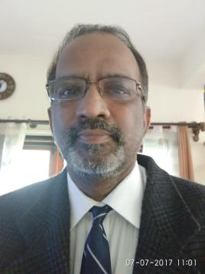
Name : Dr A M Sudhakara
Department : Computer Science
College : Institute of Engineering &Technology
Contact Details : 9342185571

Educational Details:
- UG : √
- PG : √
- Ph.D. : √
- P.D.F. :

Teaching Experience : 38 years
Research Experience : 18 years
Research Details:
- Research Area : E-security/AI/ML/DL/Data Analytics
- Funding sanctioned : ( if any)
- Publications : 32
- Conference/Workshops attended: 54
- Any other details : Member of ICANN, Fellow of IE, Vice Chairman of SVAK, Bangalore, Member ISOC, NC member of CSI-India, Editor member of CSI Communication and Editor of Multilingual Journal

